

St Teresa’s Catholic Primary School
Year 1 Writing Targets
 |  | 1 | 2 | 3 | 4 | 5
Composition | I can write sentences by saying out loud what I am going to write about
Composition | I can write sentences on my own
Composition | I can join my sentences together to make a story
Composition | I can read my sentence and check that it makes sense
Composition | I can talk about my writing with my teacher or children in my class
Composition | I can read my sentence out loud so children in my class can hear and understand me
GPS | I can add s or es to words to make them plural e.g. dog/dogs; wish/wishes
GPS | 
GPS | 
GPS | 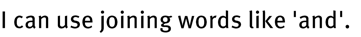
GPS | 
GPS | 
GPS | 
GPS | 
GPS | 
GPS | 
GPS | 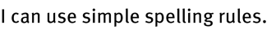
GPS | 
GPS | 
GPS | 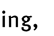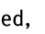
GPS | 
Handwriting | 
Handwriting | 
Handwriting | 
Handwriting | 
Handwriting | 

