ST. TERESA’S CATHOLIC PRIMARY SCHOOL, LEXDEN, COLCHESTER

Infection prevention and Control Policy
2026

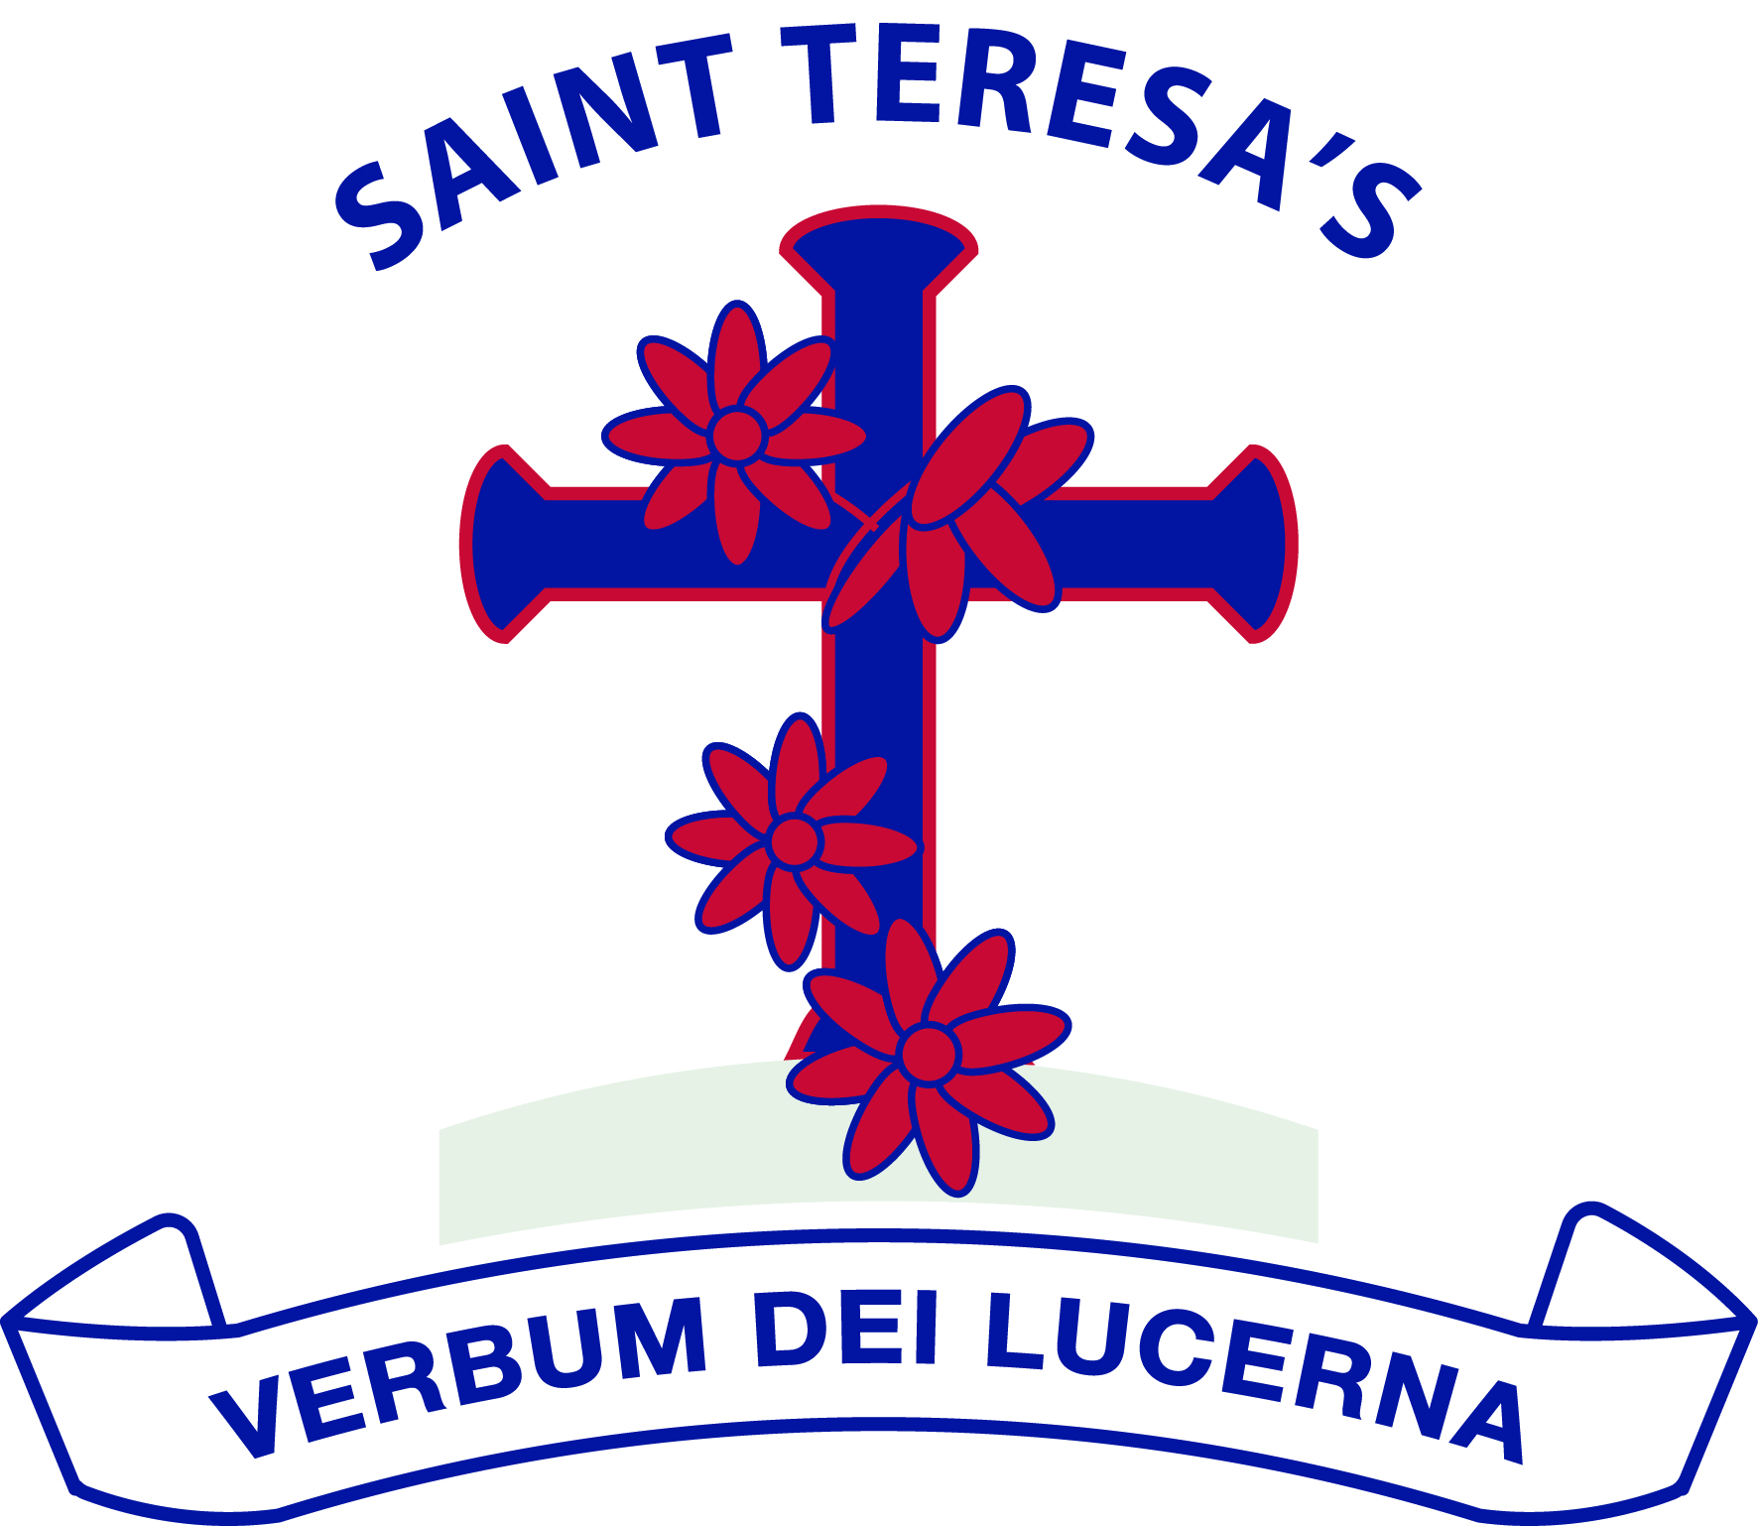

We love God and each other and follow the example of St Teresa.

We enjoy learning together and doing our best in a happy, healthy and welcoming community.

We learn to be responsible and caring citizens.

“Let us do little things well today”.

St Teresa
Approved by: | Governing Body | Date: September 2026
Last reviewed on: | August 2026
Next review due by: | September 2027

Policy Statement
St Teresa's Catholic Primary School is committed to promoting the health, safety and wellbeing of pupils by reducing the spread of infectious illness within the school community.
This policy applies to all pupils attending the school, including children within the Early Years Foundation Stage. It outlines the school's procedures for promoting good hygiene, responding when children become unwell and determining when pupils should remain away from school.
Staff absence due to illness is managed separately through the school's employment procedures. Staff are expected to use their professional judgement and return to work when they feel well enough to fulfil their duties safely.
The school follows current NHS and UK Health Security Agency (UKHSA) guidance.

Aims
- Reduce the spread of infectious illness within the school.
- Protect the health and wellbeing of pupils.
- Promote effective hygiene practices.
- Provide clear guidance regarding exclusion from school.
- Ensure children who become unwell are cared for appropriately.
- Ensure a consistent approach across the school and Early Years provision.

Promoting Good Hygiene
- Regular handwashing with soap and water.
- Handwashing before eating, after using the toilet and after outdoor play.
- Supporting younger children with handwashing where required.
- Promoting 'Catch it, Bin it, Kill it'.
- Regular cleaning of classrooms, toilets and shared equipment.
- Appropriate ventilation.
- Safe food hygiene.
- Prompt cleaning of bodily fluids using appropriate PPE.

Children Who Become Unwell
If a child becomes unwell during the school day they will be cared for appropriately, parents may be contacted and asked to collect them, and they will remain supervised until collection. Children should only attend school if they are well enough to access learning, participate safely and do not require a level of care that cannot reasonably be provided within school.

Exclusion from School
The school follows current NHS and UKHSA guidance regarding exclusion periods.

Vomiting and diarrhoea
Children who have experienced vomiting and/or diarrhoea must not attend school and may only return 48 hours after the last episode.

Chickenpox
Children should remain away from school until all blisters have crusted or scabbed over.

Other infectious illnesses
For all other infectious illnesses, including scarlet fever, impetigo, measles, mumps, hand, foot and mouth disease, influenza, conjunctivitis and whooping cough, parents should follow the latest NHS and UKHSA guidance before returning their child to school.
Parents should refer to the NHS guidance 'Is my child too ill for school?'. https://www.nhs.uk/live-well/is-my-child-too-ill-for-school/

School's Right to Refuse Attendance
The Headteacher reserves the right to refuse admission to a child who is clearly unwell or whose attendance is likely to pose a significant risk of infection to others, even where a recommended exclusion period has ended. A child may also be sent home if they are not well enough to access learning or participate safely in the school day.

Medication
Medication will be managed in accordance with the school's Supporting Pupils with Medical Conditions Policy. Medication should not be used simply to mask symptoms if a child remains infectious or too unwell to attend school.

Outbreaks
The Headteacher will seek advice from the UK Health Security Agency where appropriate, communicate with families, implement additional hygiene measures and follow public health advice.

Responsibilities

Headteacher
- Ensure the policy is implemented, seek professional advice where required and oversee the school's response to outbreaks.

Staff
- Promote good hygiene, follow infection control procedures, use PPE appropriately and support pupils who become unwell. Pupil exclusion periods do not apply to staff.

Parents and Carers
- Keep children at home when infectious or too unwell.
- Follow NHS guidance.
- Collect children promptly when requested.
- Inform the school of significant infectious illnesses.

Monitoring
This policy will be reviewed annually or sooner if national guidance changes.

References
• EYFS Statutory Framework
• NHS – Is my child too ill for school?
• UK Health Security Agency guidance

