ST. TERESA’S CATHOLIC PRIMARY SCHOOL, LEXDEN, COLCHESTER

Behaviour, Relationships and Character Policy

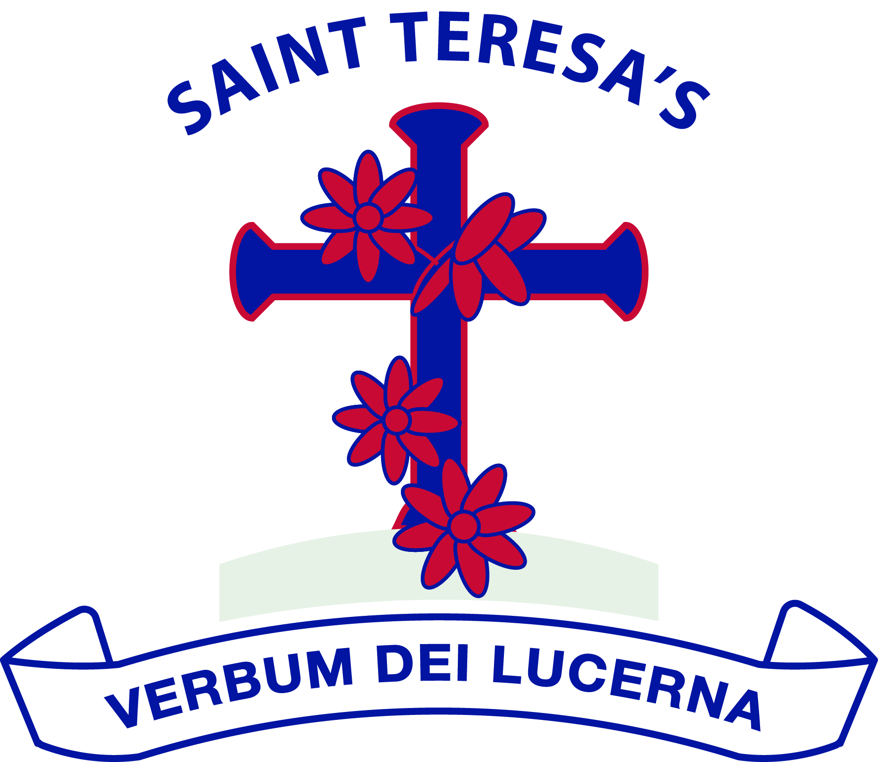

We love God and each other and follow the example of St Teresa.

We enjoy learning together and doing our best in a happy, healthy and welcoming community.

We learn to be responsible and caring citizens.

“Let us do little things well today”.

St Teresa

Approved by: | Governing Body | Date: September 2026
Last reviewed on: | /
Next review due by: | September 2028

Our Vision and Aims
At St Teresa’s Catholic Primary School, we believe that every child is created in the image and likeness of God and deserves to be treated with dignity, compassion and respect.
Our behaviour policy and behaviour curriculum are rooted in Gospel values and inspired by the example of St Teresa, who encouraged us to “do little things well.” We believe that positive behaviour is not simply expected- it is explicitly taught, modelled, practised and celebrated every day.
We have high expectations of every child because we believe every child can succeed. High expectations are matched by high levels of support. We recognise that children develop at different rates and that some require additional teaching, reasonable adjustments or specialist support to meet the same expectations as their peers.
At St Teresa’s we understand that behaviour is a form of communication. We seek to understand the reasons behind behaviour, build trusting relationships and teach children the skills they need to become responsible, respectful and resilient members of our community. We always seek to understand before we seek to sanction.
We believe that consistency creates security. Every adult has a responsibility to model the behaviour we wish to see, to build positive relationships with children and to respond calmly, fairly and consistently.
Our aim is not simply to manage behaviour, but to develop children of good character who show kindness, responsibility, honesty, forgiveness and respect both within school and beyond.
Our Behaviour Principles
At St Teresa’s we believe:
- Every child belongs
- Behaviour is taught, not assumed
- High expectations and high support go hand in hand
- Strong relationships are at the heart of positive behaviour
- Fair does not always mean the same
- Every interaction is an opportunity to teach, guide and encourage
Our Approach to Behaviour
Positive behaviour does not happen by chance. At St Teresa’s, positive social and learning behaviours are taught, practised, modelled and nurtured every day through strong relationships, clear routines and consistent expectations.
We recognise that behaviour is a form of communication. While every child is expected to meet our high expectations, we also understand that behaviour can be influenced by many factors including age, stage of development, communication needs, special educational needs and disabilities (SEND), life experiences and emotional regulation. Our role is to understand these needs whilst continuing to teach children the knowledge, skills and habits that enable them to make positive choices.
Our approach is rooted in Trauma Perceptive Practice (TPP), a relational approach which recognises that children are most likely to learn and flourish when they feel safe, understood and connected. Rather than asking, “What is wrong with this child?”, we ask, “What might this child be communicating through their behaviour?” Understanding behaviour does not remove accountability; instead, it enables us to respond in ways that build relationships, teach self-regulation and support long-term positive behaviour.
We believe that behaviour should be taught in the same way as reading, writing or mathematics. We explicitly teach routines, model expectations, provide opportunities to practise them and recognise success. Children are not expected to simply know how to behave; we teach them how.
Adults are the greatest influence on children’s behaviour. Every adult at St Teresa’s has a responsibility to model the behaviours and virtues we wish to develop in our children. We strive to be calm, consistent, respectful and compassionate in every interaction, recognising that the way adults respond can either escalate or de-escalate a situation.
Ultimately, our aim extends beyond good behaviour. Through positive relationships, explicit teaching and consistent expectations, we seek to develop children of strong character who grow in virtue and become loving, respectful, honest, courageous, compassionate, forgiving and faithful members of our school community.
The St Teresa’s Approach
Everything we do is guided by these principles:
- Behaviour is taught, not assumed
- Positive relationships come before correction
- Calm, consistent adults create calm, confident children
- We seek to understand before we seek to sanction
- High expectations are matched with high support
- Fair does not always mean the same
- Every interaction is an opportunity to build character
Our Behaviour Curriculum
At St Teresa’s, we believe that positive behaviour, strong relationships and good character are taught in the same way as any other aspect of the curriculum. We do not assume that children know how to behave; we explicitly teach the knowledge, skills, routines and habits that enable them to flourish both within school and beyond.
Our Behaviour Curriculum sets out the behaviours, routines and character traits that pupils develop progressively from Nursery to Year 6. It is designed to ensure a consistent approach across the school whilst recognising that children develop at different rates and may require different levels of support.
The Behaviour Curriculum is taught explicitly through our STRIVE curriculum and through our regular class-time sessions. It is also reinforced every day through classroom practice, collective worship, assemblies, playtimes, educational visits and the daily interactions between adults and children.
The curriculum is built around our three school expectations:
- Be Ready
- Show Respect
- Stay Safe
These expectations are explicitly taught, modelled and revisited throughout a child’s time at St Teresa’s. They provide a common language for pupils, staff and families and underpin the routines and expectations that help every child to feel safe, belong and succeed.
Our Behaviour Curriculum can be read alongside this policy.
School Expectations and Daily Routines
At St Teresa’s, consistency creates security. Clear routines help children to feel safe, understand what is expected of them and focus on learning. We explicitly teach, model and practise these routines from Nursery to Year 6, recognising that some children will require additional teaching, visual supports or reasonable adjustments to achieve success.
Arriving at School
We believe every day should begin positively. Children are welcomed onto the school site by staff and are encouraged to greet adults and one another with kindness and respect.
Children are expected to:
- Walk calmly onto the school site
- Dismount bicycles and scooters before entering the school grounds
- Wait sensibly for gates to open
- Keep mobile phones switched off and out of sight
- Hang coats and bags neatly on their allocated peg
- Begin their morning learning promptly and purposefully
Children attending Breakfast Club or wrap-around care are expected to demonstrate the same high standards of behaviour by listening carefully, using good manners, eating sensibly and following staff instructions
Around School
We take pride in our calm and welcoming environment. Children are taught to:
- Walk at all times inside the school building
- Hold doors open for others where appropriate
- Use polite manners and greet adults and visitors
- Speak quietly when moving around the school
- Take pride in caring for the school environment
We are not a silent school, but we expect movement around school to be calm, purposeful and respectful so that learning is not disturbed.
In the Classroom
Every classroom develops its own class expectations, based upon our whole-school principles. Adults explicitly teach classroom routines and consistently reinforce them so that pupils know what successful learning looks like.
Children are expected to:
- Listen respectfully when others are speaking
- Raise their hand to contribute unless another strategy has been agreed by the teacher
- Remain seated or on their carpet space during teacher input unless directed otherwise
- Participate positively in partner talk and collaborative learning
- Respect school resources and help to keep classrooms tidy
- Follow adult instructions promptly
- Demonstrate resilience and perseverance when learning becomes challenging
Learning is active at St Teresa’s. Children are encouraged to discuss their learning, work collaboratively and participate in movement breaks. Quiet reflection is equally valued during prayer, worship and periods requiring concentration.
Some pupils require visual timetables, communication supports or other reasonable adjustments. These are embedded consistently across the school using a shared visual language to promote independence and understanding.
Positive learning behaviours are recognised and celebrated through our team point system.
Collective Worship and Prayer
Collective Worship is a special time in the life of our school.
Children are taught to:
- Enter and leave worship respectfully and in silence
- Walk calmly with hands together in prayer
- Sit quietly and respectfully
- Listen attentively and participate prayerfully
These routines help create a reflective atmosphere where everyone can encounter God and worship together.
Playtimes and Lunchtimes
Play is an important part of childhood and is actively valued at St Teresa’s. Through our OPAL approach, children are encouraged to explore, cooperate, negotiate, problem-solve and take managed risks safely.
Children are taught to:
- Play safely and inclusively
- Share equipment and take turns
- Resolve disagreements respectfully, seeking adult support when needed
- Care for equipment and help tidy away resources
- Line up quickly when signalled
- Follow staff instructions promptly
In the dining hall, children are expected to:
- Demonstrate good table manners
- Speak socially without shouting
- Remain seated whilst eating
- Show courtesy and respect towards kitchen staff and one another
Adults regularly reinforce positive play through assemblies and daily conversations, helping children to develop the social skills needed for successful play.
Adults as Role Models
Every adult contributes to the culture of our school. Adults will:
- Welcome children warmly each day
- Build positive relationships with every child
- Remain calm and respectful at all times
- Listen carefully to children
- Use praise to reinforce positive behaviour
- Support children to regulate their emotions and resolve difficulties
- Follow up concerns consistently and work in partnership with families
- Model the behaviour, language and values we expect from our pupils
Children are far more likely to meet high expectations when adults model them consistently.
The End of the School Day
We believe that caring for our environment is part of respecting our school community. Children are expected to help leave classrooms tidy and organised before home time. Staff dismiss children calmly and safely, ensuring every child leaves school feeling valued and known.
Recognising Positive Behaviour
At St Teresa’s, we believe that positive behaviour grows when it is noticed, recognised and celebrated. We deliberately focus our attention on the behaviours, attitudes and character traits that help our school community flourish.
Recognition is immediate, genuine and specific. We celebrate effort, kindness, perseverance and improvement just as much as achievement. By recognising positive behaviour consistently, we reinforce the habits and values we want every child to develop.
We believe that praise is most effective when it is personal, meaningful and linked to the behaviour being recognised. Staff aim to recognise positive behaviour far more frequently than they correct inappropriate behaviour.
Our approach is guided by the principle of public praise and private correction. Children should feel valued and encouraged, whilst preserving dignity when behaviour falls below expectations. Whole-class sanctions are avoided wherever possible, as we believe behaviour should be addressed at an individual level.
Positive relationships are central to our approach. Warm interactions, smiles, greetings, welcomed physical gestures o encouragement including handshakes, high-fives, thumbs up and other age-appropriate gestures help children feel noticed, valued and successful. These everyday moments build trust, confidence and a strong sense of belonging.
We recognise positive behaviour through:
- Specific verbal praise from adults
- Non-verbal encouragement, including smiles, thumbs up, high-fives and other age-appropriate gestures
- Visual praise and encouragement
- Team Points awarded for positive learning, behaviour and character
- Celebration of the weekly winning house team and weekly merit assembly
- Positive messages shared with families through Seesaw
- Positive conversations with parents at the beginning or end of the school day
- Positive telephone calls home
- Classroom recognition, including stickers and age-appropriate praise used at the teacher’s discretion
- Headteacher recognition for exceptional work, effort or conduct, including the Golden Headteacher Award and letters home where appropriate
- Opportunities for leadership and responsibility throughout the school
Celebration of pupils who demonstrate our school values and virtues through awards such as:
- Spotted Doing Little Things Well
- Resilience
- Friendship
- Intellectual Curiosity
- Sportsmanship
- Catholic Social Teaching Champion
- Writer of the Week
Recognition is never limited to academic success. We celebrate children who demonstrate kindness, perseverance, courage, honesty, service, compassion and a commitment to living out our school values each day.
At St Teresa’s, we recognise positive behaviour because we want children to develop an intrinsic motivation to make good choices. While small rewards such as stickers may be used by class teachers, our greatest aim is for children to behave well because it is the right thing to do and because they understand the positive impact their choices have on themselves and others.
We build behaviour through relationships, explicit teaching, consistency and character development—not through fear or excessive rewards.
Responding to Poor Behaviour Choices
At St Teresa’s, we recognise that all children make mistakes. Poor behaviour choices provide opportunities to teach, restore relationships and develop character.
We understand that behaviour is a form of communication. When behaviour falls below our expectations, we seek first to understand what may be contributing to the behaviour whilst maintaining clear expectations and appropriate boundaries.
Where appropriate, staff will gather information by listening to the child, speaking to those involved and establishing the facts before deciding upon the most appropriate response.
Our response to poor behaviour aims to:
- Keep everyone safe
- Help children understand the impact of their behaviour
- Restore relationships where appropriate
- Teach the behaviour we want to see in the future
- Apply fair and proportionate consequences where necessary
Consequences are intended to support learning rather than punish. They should always be reasonable, proportionate and linked, wherever possible, to the behaviour that has occurred.
Examples may include:
- A restorative conversation
- A verbal or written apology
- Repairing or replacing damaged property where appropriate
- Helping to tidy or restore an area
- Repeating work where effort has deliberately fallen below expectations
- Completing missed learning
- Missing part of a break or lunchtime where behaviour has been repeated or where reflection is required
- Our focus is always on helping children make better choices in the future
Graduated Response
Where poor behaviour is repeated or becomes more serious, staff will follow the school’s graduated behaviour response. This ensures that children receive increasing levels of support alongside appropriate consequences.
This may include:
- Additional restorative conversations
- Increased communication with parents and carers
- Support from senior leaders
- Behaviour reports with agreed daily targets
- Individual Behaviour Support Plans
- Pastoral interventions
- Individual risk assessments where appropriate
- Involvement of external agencies
Behaviour reports provide children with regular opportunities throughout the day to reflect upon and improve their behaviour. These are reviewed regularly with parents and carers to celebrate success and identify next steps.
Where appropriate, Individual Behaviour Support Plans may include personalised strategies, agreed scripts, reasonable adjustments and individual consequences informed by professional advice.
The school’s Behaviour and Consequences Chart provides staff with operational guidance to ensure consistency and should be read alongside this policy.
Recording and Monitoring
Behaviour incidents are recorded on CPOMS in accordance with the school’s recording procedures. Records are reviewed regularly by senior leaders to identify patterns, monitor trends and ensure that appropriate support is in place.
Staff are encouraged to seek advice and support from senior leaders whenever behaviour becomes a recurring concern.
Serious incidents, including bullying, racist incidents, harmful sexual behaviour, discriminatory incidents and other hate-related incidents, are recorded and investigated appropriately. These are managed by the Senior Leadership Team and responded to in accordance with this policy, the Anti-Bullying Policy and the school’s safeguarding procedures.
Inclusion: High Expectations, High Support
At St Teresa’s, we believe that every child is unique, created in the image and likeness of God, and entitled to an exceptional education. Every child possesses inherent dignity and deserves to feel safe, valued, respected and able to flourish within our school community.
Inclusion means ensuring that every child belongs. We recognise that children learn, communicate and regulate in different ways. Whilst our expectations remain consistently high for every pupil, the support, teaching, reasonable adjustments and strategies used to help children succeed may differ according to individual need.
We believe that high expectations and high support go hand in hand. We do not lower expectations because a child has SEND or experiences barriers to learning. Instead, we adapt our teaching, environment and approaches to enable every child to achieve success.
We recognise that behaviour and SEND are closely linked; however, dysregulation is not necessarily poor behaviour. Where a child is experiencing dysregulation associated with a recognised need, our priority is to support co-regulation, understanding and recovery rather than viewing the incident simply as a behaviour concern. Observations of dysregulation are monitored to help us understand patterns and inform provision. Deliberate or defiant behaviour will continue to be responded to in line with this policy.
Children may require reasonable adjustments to help them achieve success. These adjustments are carefully planned and may include visual supports, Widget symbols, personalised timetables, now-and-next boards, movement or sensory breaks, adapted transitions, communication supports, alternative methods of recording, sensory resources, predictable routines, agreed scripts or individual curriculum adaptations. We recognise that different children need different support and that fair does not always mean the same.
Adults use calm, consistent and relational approaches to support children who become dysregulated. Wherever possible, adults seek to co-regulate before expecting self-regulation. Time, space, clear language, visual supports, choices, distraction, movement and agreed regulation strategies may all be used to help children feel safe and ready to learn again.
Some pupils may require Individual Behaviour Support Plans or individual risk assessments. These are developed collaboratively by the SENCO, senior SEND staff, parents and, where appropriate, the child themselves. Advice from external professionals may also inform these plans to ensure that support is personalised, evidence-informed and effective.
We work closely with families because we believe the strongest outcomes are achieved when school and home work together. Regular communication, Team Around the Family (TAF) meetings and multi-agency working help ensure that children receive joined-up support. Wherever possible, support and intervention will be explored before more serious behaviour sanctions are considered.
What we don’t do
Our approach is underpinned by respect and dignity. We do not use shouting, humiliation or sarcasm as behaviour management strategies. We believe in forgiveness, fresh starts and helping children to rebuild confidence following mistakes. We recognise that some children hear far more correction than praise in their daily lives and we deliberately seek opportunities to notice success, celebrate strengths and build positive self-esteem.
In Early Years
In our Nursery and Early Years provision, we recognise that very young children are still developing communication, emotional regulation and social interaction skills. Behaviour is taught through nurturing relationships, modelling and developmentally appropriate support. Some behaviours, such as biting, may form part of typical early childhood development and are responded to in accordance with the school’s Biting Policy. Our expectations remain high, but our approaches are always age and stage appropriate.
Serious Behaviour
We are committed to supporting every child to succeed and take every reasonable step to avoid suspension or permanent exclusion.
In exceptional circumstances, where behaviour places the safety, wellbeing or education of others at significant risk, the Headteacher may consider suspension or permanent exclusion in accordance with the school’s Suspension and Exclusion Policy and current statutory guidance.
The Headteacher reserves the right to suspend or permanently exclude, in line with statutory guidance, where there has been a serious one-off incident or where a persistent pattern of behaviour places the safety, wellbeing or education of others at significant risk.
Restrictive physical intervention is only ever used to prevent harm and only where it is lawful, reasonable, proportionate and absolutely necessary. Further guidance is contained within the school’s Restrictive Intervention Policy.
Serious Behaviour and Safeguarding
At St Teresa’s, every child has the right to feel safe, respected and valued. We recognise that some behaviours go beyond poor behaviour choices because they place the safety, dignity or wellbeing of others at risk. These behaviours require an immediate, robust and proportionate response.
Certain behaviours are never acceptable within our school community. These include, but are not limited to:
- Bullying
- Racist incidents
- Discriminatory behaviour or language, including behaviour relating to disability, race, religion, sex or sexual orientation
- Harmful sexual behaviour or sexual harassment
- Violence or deliberate physical aggression
- Threatening or intimidating behaviour
- Hate-related incidents
- Serious damage to property
All serious incidents are investigated thoroughly. Staff will listen carefully to those involved, gather evidence where appropriate and ensure that responses are fair, proportionate and based upon the facts.
Parents and carers will be informed of serious incidents and, where appropriate, external agencies may be involved to support the child, family or school.
Bullying is not tolerated at St Teresa’s. We believe that every child has the right to attend school free from fear, intimidation and harassment. Allegations of bullying are investigated promptly and responded to in accordance with the school’s Anti-Bullying Policy. Alongside appropriate sanctions, we seek to educate, restore relationships where possible and prevent future incidents. Repeated bullying behaviour will result in increasingly serious consequences.
Serious incidents, including bullying, racist incidents, discriminatory behaviour, harmful sexual behaviour and other safeguarding concerns, are recorded on CPOMS and monitored by senior leaders and Governors. These records help identify patterns, inform support and ensure that appropriate action is taken.
Where behaviour raises safeguarding concerns, safeguarding procedures will always take precedence. Staff will respond in line with the school’s Safeguarding and Child Protection Policy and work closely with external agencies where necessary.
Confiscation of Items
Staff have the authority to confiscate items that are unsafe, prohibited, disruptive to learning or contrary to the school’s expectations. Confiscated items will be managed in accordance with Department for Education guidance, and parents will be informed where appropriate. Searches and confiscation will always be conducted lawfully, respectfully and proportionately.
Behaviour outside school
Behaviour outside school, including online behaviour, may also be addressed where it has an impact on the safety, wellbeing or education of members of the school community.
Moving on from serious behaviour
Whilst we respond firmly to serious behaviour, we continue to believe in the possibility of change. Through clear boundaries, education, support and reconciliation, we seek to help every child learn from their mistakes and move forward with dignity and hope.

Roles, Responsibilities and Monitoring
Positive behaviour is everyone’s responsibility. At St Teresa’s, we believe that children flourish when schools and families work together with shared expectations, mutual respect and open communication.
Governing Body
The Governing Body is responsible for:
- Approving and reviewing this policy
- Monitoring the effectiveness of the school’s behaviour culture
- Challenging leaders to ensure behaviour is effectively promoted across the school
- Reviewing behaviour information and trends
- Carrying out its statutory responsibilities in relation to suspension and permanent exclusion, including considering representations and appeals in accordance with current legislation
Headteacher
The Headteacher is responsible for:
- Ensuring the consistent implementation of this policy
- Promoting a positive culture of behaviour, relationships and character
- Supporting staff and ensuring appropriate training
- Monitoring behaviour across the school
- Making decisions regarding suspension and permanent exclusion in accordance with statutory guidance
- Reporting behaviour trends to governors
Senior Leaders
Senior leaders are responsible for:
- Supporting staff in implementing this policy consistently
- Modelling excellent practice
- Coaching and supporting colleagues where behaviour concerns arise
- Analysing behaviour information, CPOMS records and safeguarding information regularly to identify patterns and emerging concerns
- Planning interventions and supporting staff to improve outcomes for pupils
- Working in partnership with families and external agencies where appropriate
All Staff
Every member of staff is responsible for:
- Building positive relationships with pupils
- Teaching the Behaviour Curriculum
- Maintaining high expectations alongside high levels of support
- Applying this policy fairly and consistently
- Recording behaviour appropriately
- Working in partnership with parents and carers
- Modelling the behaviour, language and values expected of pupils
Parents and Carers
Parents and carers play a vital role in supporting positive behaviour. We ask parents and carers to:
- Support the school’s expectations and values
- Model respectful behaviour and positive relationships
- Ensure children arrive at school ready to learn
- Work in partnership with school staff to support their child
- Communicate concerns respectfully so that solutions can be found together
Pupils
All pupils are expected to:
- Follow the Behaviour Policy and engage in our Behaviour Curriculum
- Be Ready, Show Respect and Stay Safe
- Work hard to make positive behaviour choices
- Take responsibility for their actions
- Treat others with dignity, kindness and respect
- Contribute positively to our school community
Monitoring and Pupil Voice
Behaviour is monitored regularly to ensure that our provision continues to meet the needs of all pupils. We believe that pupils should have a voice in shaping our school community. Through School Council, pupil leadership opportunities, surveys and regular conversations, we actively seek pupils’ views about behaviour, relationships, safety and belonging. Their feedback helps us review and continually strengthen our Behaviour, Relationships and Character Policy.
Related Policies
- Anti-Bullying Policy
- Safeguarding & Child Protection Policy
- Suspension & Permanent Exclusion Policy
- Restrictive Intervention Policy
- SEND Policy
- Attendance Policy
- Online Safety / Acceptable Use
- Behaviour Curriculum
Evidence-Informed Practice
- Department for Education statutory guidance
- Trauma Perceptive Practice (Essex)
- Charlie Taylor’s principles of behaviour
- Paul Dix’s relational approach
- Catholic Social Teaching and the Bishop’s Virtues

Reviewed by B. Maguire, Headteacher, July 2026

