ST. TERESA’S CATHOLIC (AIDED) PRIMARY SCHOOL, LEXDEN, COLCHESTER

Wrap Around Care Policy

Early Bird Breakfast Club, Universal Free Breakfast Club (UFBC) & After School Club

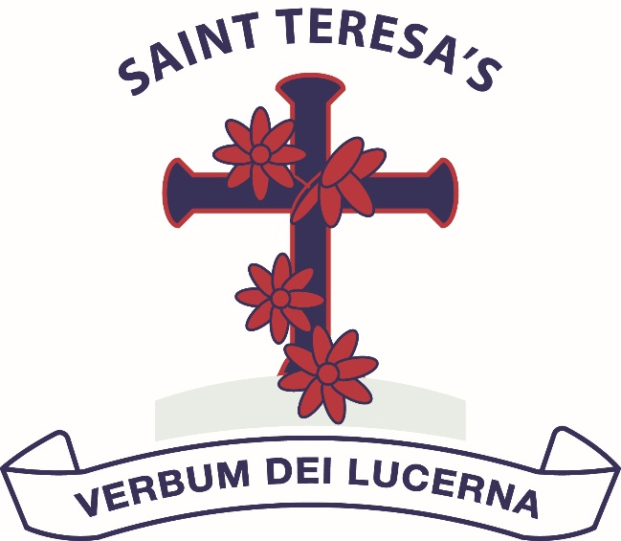

Approved by: | Governing Body | Date: 14th May 2024
New Policy Date: | February 2026
Next review due by: | April 2027

Aims
St Teresa’s wrap-around care was set up to support parents by providing early morning childcare and after school childcare.

Wrap around care provides a welcoming, safe, secure and friendly environment for the children to enjoy healthy food to start and end their day as well as activities to engage them.

Although breakfast or a light tea are provided, some children would prefer to eat at home and will come to wrap-around provisions just to take part in the many activities and receive childcare.

Early Bird Breakfast and Universal Free Breakfast Club
EY, KS1 and KS2 Early Bird Breakfast Club takes place in the school hall and Hive respectively, Universal Free Breakfast Club takes place in the church hall. Both run Monday to Friday term time only. Places are available to all age groups from Reception Class to Year 6. The times for Early-Bird are 7.30– 8.45am. Universal Free Breakfast Club begins at 8:15am and runs till 8:45am. At the end of the sessions EY and KS1 children are taken to class by a staff member. KS2 children are escorted onto the front playground.

After School Childcare
EY, KS1 and KS2 are split across two after school wrap-around provisions. The sessions run Monday to Friday 3:15 – 6:00pm term time only. Wrap-around club is held in the School Hall, The Hub and the Harbour. After school wrap-around does not run on the last day of any full term (Christmas, Easter and Summer holidays).

A half-wrap-around option is given to nursery parents (3:10pm-4:30pm)

Staff
Staffing ratios are set according to booked numbers of pupils considering any Nursery/EYFS pupils. The overall manager of wrap-around care is the headteacher. All members of staff have First Aid certificates and Food & Hygiene certificates. All staff have received Safeguarding training.

Booking arrangements and Costs

Spaces are booked via Parent Pay (YR to Y6) or via Ovivio (formally Blossom) for Nursery pupils.

Payment should be made in advance.

The cost of Early-Bird breakfast session is £3.90 however this is then subsidised by the UFBC by £1 per pupil per day, bringing the total to £2.90 for YR-6 pupils per day.

The cost of after school childcare for YR- 6 is £10 per session. All payments to be made via Parent Pay. Tax-free child care is also accepted.

Nursery costs (as of 1st September 2026) reflect the ratio of qualified adult supervision. Nursery breakfast costs £6.50, half-wrap-around costs £9.25 and full wrap-around £17.50.

There is a list of emergency contact numbers for each child held in the breakfast club/after school club folder with the register so that parents can be contacted if necessary before the office is open.

All YR-6 Breakfast Club and Wrap-Around costs are reviewed annually in April. Nursery costs are reviewed annually in September.

Organisation of Early Bird Breakfast Club
All children must be brought to the breakfast club room door by their parent or guardian. In KS2, children sign themselves in. Children should not be left to enter the club alone or before 7.30am.

Once the children have entered breakfast club they then hang up their coats and bags. A staff member will ask them what they want for breakfast. They then wash their hands before they take their place at the breakfast table. The children are encouraged to pour their own drinks and butter their own toast or pour the milk into their cereals.

There are a variety of cereals available as well as toast and butter with or without jam, dried fruit, yoghurt, fruit, a variety of bread products (bagel, muffin, crumpets etc.). The children can have apple or orange juice, milk or water to drink. In the winter months hot chocolate is available to the children.

When the children have finished their breakfast, they clear away their plates and cups etc. and then go to one of the activity tables to take part in either a structured activity or play a board game, play with the Lego, draw or take part in one of the many activities that are on offer each day.

The children tidy up at the end of each session.

Universal Free Breakfast Club (UKBC)

St Teresa’s is part of a Government pilot scheme during the summer term of 2025, we are known as an ‘early-adopter’ UFBC. UFBC is open to all pupils in all year groups and is free of charge.

UFBC runs from 8:15am to 8:45am.

UFBC is situated in the Church hall and is mixed Reception-KS1 and KS2. A simple breakfast and activities are available.

Parents must complete an initial registration to use UFBC, after this there is no need to book, but pupils must always be signed in on arrival.

Organisation of After School Club
Children are brought or bring themselves (in older year groups) to the school hall directly at the end of the school day. From the hall children are registered and given stickers if they are attending other clubs in order that the club leader knows they are to be dropped back to wrap-around afterwards. A variety of indoor, outdoor, quieter and noisier activities, which are rotated, can be enjoyed.

A light tea is provided at around 4:30pm. Menus are published on a three-week rolling rota.

Parents should collect from the foyer (alerting staff by ringing the labelled bell).

Children are encouraged to assist with tidying away activities.

First Aid
There is a first aid box situated in both breakfast club and after school club for any minor accidents that may occur. The details of any accident should be entered into the main accident book in the medical room.

Resources
Breakfast club and After school have their own supply of craft resources, games and tableware. These are kept in the room that is used.

Fire Safety
Breakfast club and after school club have their own fire drill termly. The time of evacuation is recorded each time. The children know that they are to leave the room, in an orderly fashion, via the door into the playground and line up along the designated spaces. The register is taken out of the room and checked to make sure that all children and staff have left the building.

Please be advised that the terms and conditions may be subject to change.

