ST. TERESA’S CATHOLIC PRIMARY SCHOOL, LEXDEN, COLCHESTER
Freedom of Information (FOI) Policy

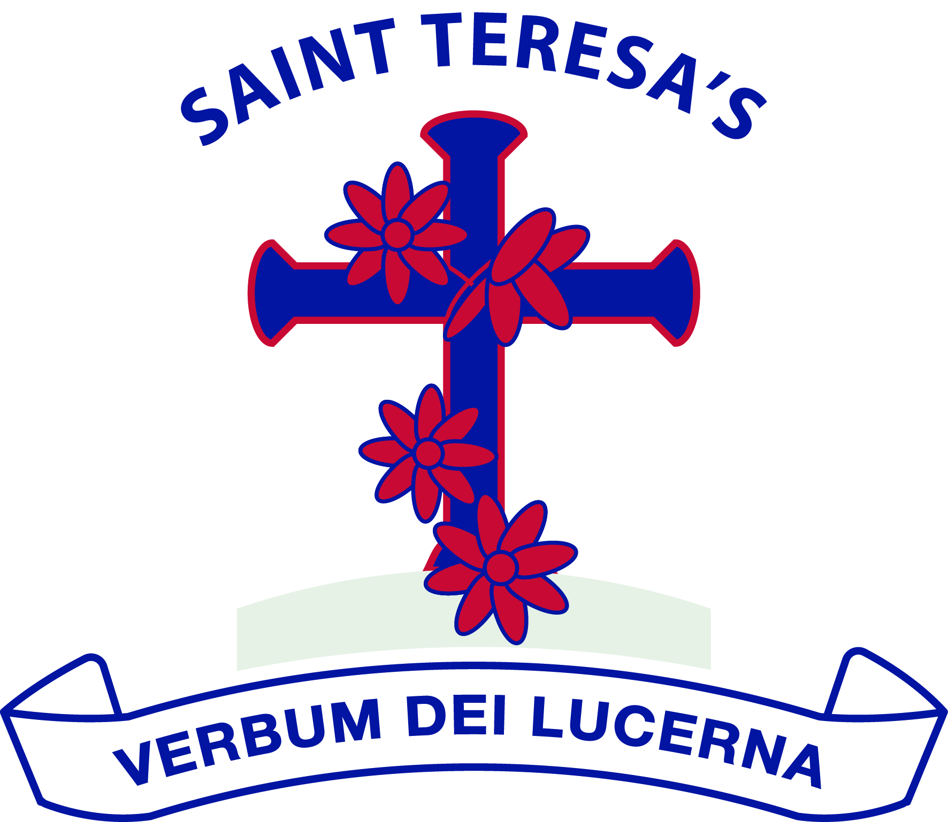

We love God and each other and follow the example of St Teresa.
We enjoy learning together and doing our best in a happy, healthy and welcoming community.
We learn to be responsible and caring citizens.
“Let us do little things well today”.
St Teresa

Approved by: | Governing Body | Date: February 2026
Last reviewed on: | February 2026
Next review due by: | February 2029

Freedom of Information Policy
St Teresa’s Catholic Primary School have aligned this policy with the Freedom of Information Act 2000, Data Protection Act 2018, UK GDPR, and the Confidentiality Policy.
1. Purpose of the Policy
This policy sets out how St Teresa’s Catholic Primary School complies with its duties under the Freedom of Information Act 2000 (FOIA). It explains how requests for information are handled, what information is routinely published, and how FOIA operates alongside data protection and confidentiality requirements.
2. Legal Framework
This policy should be read in conjunction with:
• Freedom of Information Act 2000
• Data Protection Act 2018
• UK General Data Protection Regulation (UK GDPR)
• Environmental Information Regulations 2004
• School Data Protection Policy
• Confidentiality Policy
• Records Management Policy
3. Scope
This policy applies to all recorded information held by the school, including paper records, electronic files, emails, and photographs, created or received in the course of the school’s business.
4. Responsibilities
• The Governing Body has overall responsibility for ensuring compliance with FOIA.
• The Headteacher is responsible for operational compliance and decision-making.
• The School Office is responsible for receiving, logging, and coordinating responses to requests.
• All staff are responsible for identifying and forwarding FOI requests promptly.
5. Publication Scheme
The school adopts the Information Commissioner’s Office (ICO) Model Publication Scheme and publishes information proactively via:
• The school website
• School policies and statutory information pages
• Governing body information
6. Making a Freedom of Information Request
Requests:
• Must be made in writing
• Must include sufficient detail to identify the information requested
• Do not require the requester to give a reason
Requests should be submitted to: office@st-teresas.essex.sch.uk or via the school office.
7. Timescales for Response
The school will respond promptly and no later than 20 school days after receipt.
8. Exemptions and Refusals
Some information may be withheld under FOIA exemptions, including but not limited to:
• Personal data (protected under UK GDPR)
• Safeguarding and child protection information
• Confidential staff information
• Commercially sensitive information
• Legal privilege
• Information whose disclosure would prejudice effective conduct of public affairs
Where information is withheld, the school will explain the reason and the exemption applied.
9. Relationship with Data Protection and Confidentiality
Requests for personal data will be treated as Subject Access Requests (SARs) under UK GDPR, not FOIA.
The school will always consider its duty of confidentiality and safeguarding before disclosure.
10. Charges
Most information is provided free of charge. Charges may apply for:
• Photocopying
• Printing
• Postage
Any charges will be communicated in advance.
11. Complaints and Appeals
If a requester is dissatisfied, they may request an internal review by the Headteacher.
If still dissatisfied, complaints may be escalated to the Information Commissioner’s Office.
12. Monitoring and Review
This policy will be reviewed every three years or sooner if legislation changes.

