ST. TERESA’S CATHOLIC PRIMARY SCHOOL, LEXDEN, COLCHESTER

Geography Policy

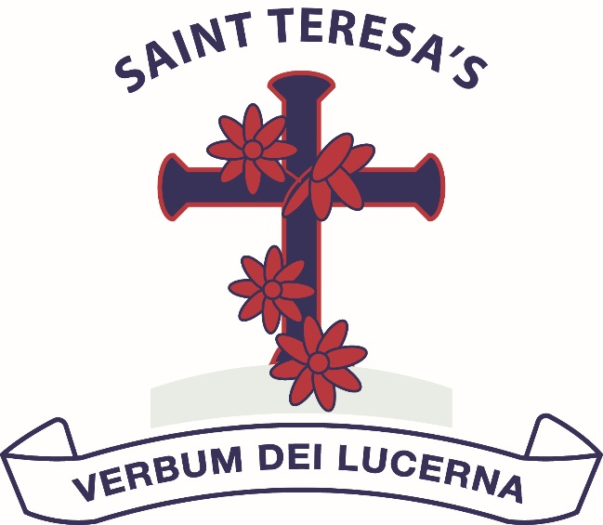

Approved by: | Governing Body | Date: February 2026
Policy reviewed Date: | Spring term 2026
Next review due by: | Spring term 2028

MISSION STATEMENT

We love God and each other and follow the example of St Teresa.

We enjoy learning together and doing our best in a happy, healthy and welcoming community.

We learn to be responsible and caring citizens.

“Let us do little things well today”.

St Teresa

Introduction

This policy outlines the teaching, organization and management of the Geography taught at St. Teresa’s Catholic Primary School.

Curriculum Intentions:
Our Curriculum’s intention is to provide ‘endless possibilities and opportunities’. Teachers provide every opportunity for the children, through rich experiences, to thrive in our society and community; teaching them the skills and knowledge for jobs of the future that do not yet exist. The curriculums in each year group have each been carefully designed, delivered and evaluated using each skill from the National Curriculum, building on the children’s prior knowledge and skills from previous years. We aim to provide every possibility for each individual (regardless of their starting points) to acquire knowledge, challenge, apply and use skills in a creative, fun, inspiring and enriching environment.

Underpinning the foundation curriculum is critical thinking to enable rich learning experiences in a student lead and engaging atmosphere. Our intention, at St Teresa’s, is to provide depth within the subjects being taught. Together, we develop the competencies and dispositions that will prepare our children to be creative, connected and lifelong problem solving learners. We enhance reading, writing, phonic and mathematical skills in a cross curricular way to provide an enjoyable curriculum. This enables our pupils to thrive using the important skills to communicate and provide each pupils with the foundations for the future.

Geography intent:
The intention of the Geography curriculum at St Teresa's Catholic Primary School is to inspire children’s curiosity and interest to explore the world that we live in and its people, which aims to ignite a love of learning .We believe that high quality geography education is paramount to ensuring our children are full of curiosity, fascination and excitement about the world and its people which will remain with them for the rest of their lives. We believe that our teaching, through a rich, varied and creative curriculum, will equip pupils with knowledge about diverse places, people, resources and natural and human environments, together with a deep understanding of the Earth's key physical and human features.

Through our teaching of the foundation curriculum we aim to:

Geography

- become geographers
- stimulate pupils' interest in and curiosity about their surroundings and the changing world
- encourage pupils to ask questions and propose solutions to environmental problems
- develop pupils' competence in specific geographical skills
- foster a sense of responsibility for the earth and its resources
- encourage children to go outside and experience geography first hand

Through the teaching of Geography we can also:

- Improve pupils' skills in English, Mathematics and computing
- Develop pupils' critical thinking skills
- Promote pupils' awareness and understanding of gender, cultural, spiritual and moral issues
- Develop pupils as active citizens of the world, understanding global and local issues
- Develop a creative outlook
- Understand and use British Values

Implementation
Teaching Strategies

Learning and teaching in the foundation subjects will be in line with the school’s Teaching and Learning Policy, where provision is made for all learning styles.

- Most of the foundation curriculum is taught through whole school cross-curricular topics that ensure coverage of the National Curriculum objectives and Key Skills, as well as St Teresa’s enriched curriculum objectives.
- History and Geography are taught at least two terms out of the three terms. In some cases, History and Geography are taught in blocks, in other cases they are interweaved throughout a curriculum topic of study. This is in order to complement their curriculum studies. For one term of the year, the focus should be on a STEM topic to raise the profile of STEM subjects in our school. Teachers can choose which order they teach the Geography and History units of study and skills, taken from the skills progression map.
- Class teachers use the cross-curricular Long Term Plans in the form of a topic web, this indicates what they can teach in any term. The teachers then map out when and how this will be taught in subject specific medium terms plans and then further, more detailed individual lesson plans can be produced if required, dependent on experience and expertise.
- Pupils work in a variety of contexts - individually, in groups and as whole classes.
  - They present their knowledge and understanding in a variety
of ways
  - Fieldwork and visits are a purposeful and integral part of the curriculum. Fieldwork in geography is considered a core skill and is planned for and carried out accordingly.
  - Outdoor learning and the opportunity for out of school experiences is valued and integral to teaching. This can be local or further afield. Outdoor learning is an invaluable learning resource.
  - Use of artefacts should be made as often as possible to make learning hands on and real to the children, grasping a deeper understanding of history or geography
  - Solve non-routine problems and use critical thinking skills using their learned knowledge in a safe environment to challenge, make decisions and justify their answers.
  - Entrepreneurial skills

When teaching Geography we:

- Always explain what Geography is
- Always explain what we want pupils to know using ‘Can I…?’ questions, what we want them to understand and want them to be able to do
- Introduce and revisit subject specific vocabulary
- Use key questions to direct pupils' thinking / enquiry in more depth, building on provided answers
- Vary the resources and activities to ensure each pupil can learn effectively
- Cater for all learning styles and abilities through effective differentiation
- Ensure the foundation subjects are given equal/ sufficient weighting in teaching time
- Ensure displays are rich and vibrant and purposeful to learning
- Celebrate the achievements of pupils
- Enable the opportunity for pupils to develop scholarship through setting of home work projects and tasks.
- Involve the parents

Equal Opportunities

In line with our Equal Opportunities Policy we are committed to providing a teaching environment conducive to learning. Each child is valued, respected and challenged regardless of race, gender, religion, social background, culture or disability.

Inclusion
All children receive quality first teaching and activities are differentiated according to children’s needs. Appropriate support is put in place where identified pupils are considered to require targeted support to enable them to work towards age appropriate objectives.

Resources

We have a wide range of resources to support the teaching of the foundation subjects across the Key Stages including texts, artifacts, videos, website subscriptions, photographs, maps, atlases and computing software and hardware. These are mostly stored in the main resources room along within the art cupboards. It is vital that the pupils experience the topic through the use of resources and links should be made as frequently as possible.

Trips and Visitors

Class teachers should ensure there is at least one visit every term and one visitor, linking the core skills of history, geography or STEM into the real-life application of a trip. Teachers should make the most of the trip, exploring the locality to make the trip a whole day, worthwhile trip for the pupils and curriculum. At least one trip each year should be ‘further afield’ in order to teach the pupils about the topic outside of the locality. Teachers should ensure trips meet the objectives needed for the subject area and many objectives may be cross-curricular. Teachers should ensure they have read the Trips Policy, carry out preliminary visits and of course complete a thorough risk assessment.
Sometimes, there may be opportunities for visitors to come into schools. Visitors provide:
- Immediate impact from their real-life experiences
- Create opportunities for children to question, relate to experiences, reflect and challenge respectfully
- Pupils with a fresh view, insight or new ideas for their development and learning
- See life from a different perspective

Health and Safety

This needs to be read alongside our Health and Safety Policy and Off Site Activities Policy.

Assessment and Record Keeping

To assess pupils' progress in the foundation subjects we:

- Gather evidence of what individual pupils know, understand and can do in Geography by observing them at work, listening to and discussing with them and evaluating work they produce.
- At the end of each cross-curricular topic, we record against the National Curriculum objectives covered on Target Tracker. Teachers are encouraged to update the skills the children have proved they know regularly to build a picture over time and reduce the assessment workload at the end of a term. This information is collected 3 times a year where subject leaders can monitor attainment and progress across the curriculum. Regular highlighting of skills attained on Target Tracker as part of the marking and feedback process reduces the workload of teachers each term.
- Every term, teachers will produce a well-presented topic evidence book, to illustrate the range of activities covered by the pupils. This is monitored for progression of skills, curriculum coverage and showcasing broad, balanced and rich curriculum experiences.
- Teachers will make an assessment of progress against the National Curriculum expectation for each child as part of the child’s annual report to parents.
- We use designated learning objectives from the National Curriculum in the form of ‘Can I…?’ questions.
- Marking in the foundation subjects is of equal quality to marking in other subjects, excellence as standard. Verbal feedback to move children’s learning on and plug gaps in learning is encouraged in the foundation subjects, as well as the core subjects.

Monitoring and Evaluation

The monitoring of the standards of children’s work is the responsibility of the curriculum leader. This is carried out through monitoring of teachers medium term planning, scrutinies of children’s work and pupil perception interviews, review and evaluation of termly topic evidence books, scrutiny and monitoring of displays around the school. Annual evaluations will be made against medium term plans as part of an ongoing working document. These will be given to the head teacher and curriculum leader at the end of the year to show impact of actions. This sits alongside individual subject action-plans.

The Role of the Geography Leader is to:

- Manage teaching and learning and the impact of such in Geography
- Inspire an enthusiasm for the foundation subjects and advise staff when necessary
- Ensure continuity of progression in work across the key stage and coverage of the National Curriculum and St Teresa’s enrichment curriculum
- Write and evaluate annual action-plans
- Monitor pupils’ work in order to see progression and continuity
- Act in an advisory capacity and encourage “outstanding practice”, including arranging and leading CPD opportunities for staff and through the effective use of staff meeting time.
- Promote a cross-curricular approach to computing in geography
- Maintaining all materials and resources, ordering new resources as required and in line with up-to-date trends and needs
- Ensure assessment of foundation subjects is accurate
- Take the lead in policy development and update the policy when required
- Liaise with other subject leaders to ensure continuity and commonality in assessment approaches, recording and evidencing of work.
- Keep Governors informed of changes to policy and matters of Curriculum and Assessment.

Reviewed:

Approved by Governors: February 2023
Reviewed: February 2026
To be reviewed: February 2028

