ST. TERESA’S CATHOLIC PRIMARY SCHOOL, LEXDEN, COLCHESTER

Art and Design Technology Policy

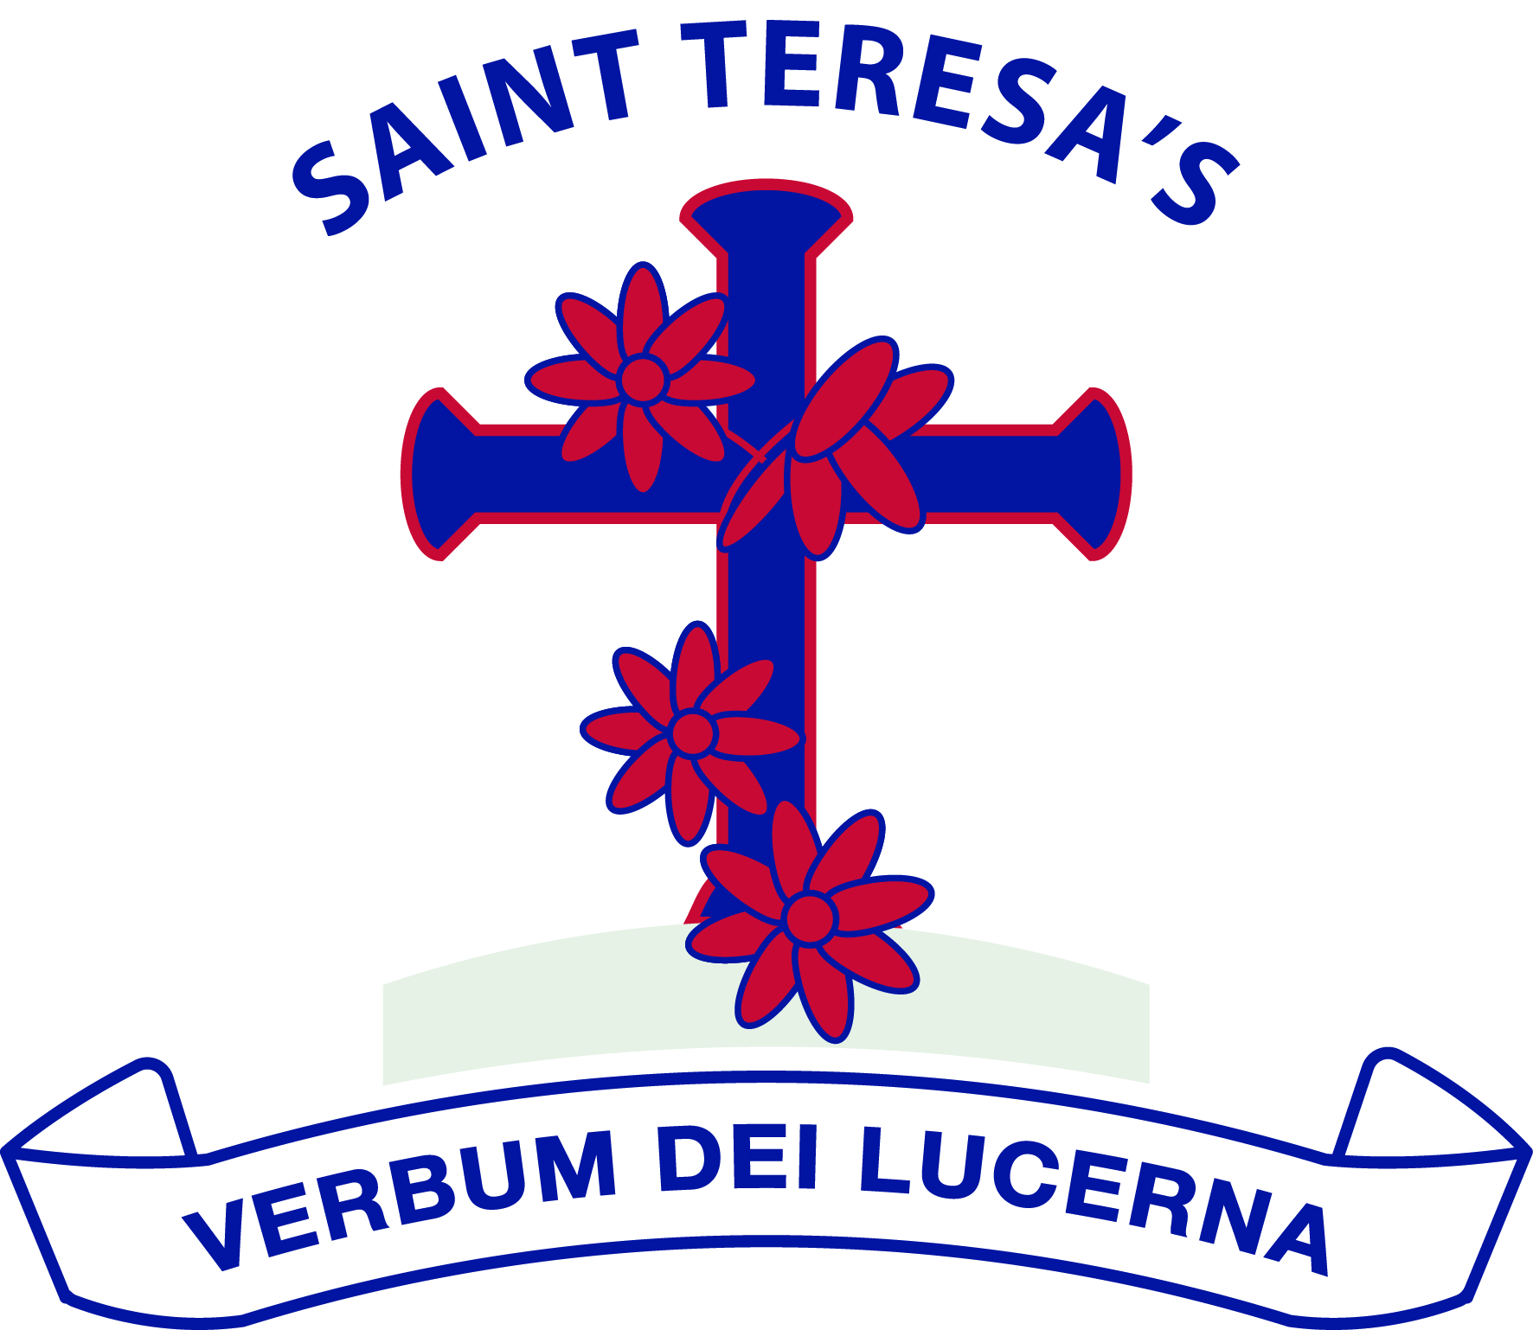

We love God and each other and follow the example of St Teresa.

We enjoy learning together and doing our best in a happy, healthy and welcoming community.

We learn to be responsible and caring citizens.

“Let us do little things well today”.

St Teresa

Approved by: | Governing Body | Date: February 2026
Last reviewed on: | September 2025
Next review due by: | September 2028

Introduction

This policy outlines the teaching, organisation and management of Art and D.T taught at St.
Teresa’s Catholic Primary School.

Curriculum Intentions:
Our Curriculum’s intention is shaped by our school vision and ethos to support our children to become curious and creative learners to help them flourish and achieve their very best.
St Teresa’s provides every opportunity for the children through rich experiences to thrive in our society and community; teaching them the skills and knowledge for jobs of the future that do not yet exist. The curriculums in each year group have each been carefully designed, delivered and evaluated using each skill from the National Curriculum, building on the children’s prior knowledge and skills from previous years. We aim to provide every possibility for each individual (regardless of their starting points) to acquire knowledge, challenge, apply and use skills in a creative, fun, inspiring and enriching environment.
Underpinning the foundation curriculum is critical thinking to enable rich learning experiences in a student lead and engaging atmosphere. Our intention, at St Teresa’s, is to provide depth within the subjects being taught. Together, we develop the competencies and dispositions that will prepare our children to be creative, connected and lifelong problem-solving learners. We enhance reading, writing, phonic and mathematical skills in a cross curricular way to provide an enjoyable curriculum. At the heart of our schools curriculum is our religious nature therefore we enhance our R.E learning through artistic outcomes and studies of exemplary religious art. This enables our pupils to thrive using the important skills to communicate and provide each pupil with the foundations for the future.

Intention Art:
At St Teresa’s Catholic Primary School our aim for teaching Art and Design is that it is embedded throughout the curriculum and that we ensure opportunities to: develop ideas, master techniques, take inspiration from great artists and to be able to evaluate work completed.
We strive to stimulate the creativity, imagination and inventiveness of our students whilst teaching them the skills, concepts and knowledge needed for them to develop their own critical thinking techniques, in order that they can confidently express ideas, ask questions, problem solve and evaluate their individual experience of Art and Design.

D.T:
At St Teresa’s Catholic Primary School our aim for design and technology is to embed all the learning through our personalised topics, ensuring opportunities for students to follow the whole process from designing, to making, to evaluating their own and others’ work. Using creativity and imagination, pupils will design and make their own products linked to real life, within a variety of topics, considering design criteria. We always aim to give our learning purpose and allow children to explore the knowledge and cultural capital they need in order to succeed in life. We strive to select and use appropriate tools safely and effectively to create products.

Through our teaching of the foundation curriculum we aim to:

Art

- For children to become reflective artists.
- For children to become experienced in drawing, painting, sculpture as well as craft and design techniques.
- To enable children to record from first-hand experience and imagination, and to select their own ideas to use in their work
- To be able to evaluate in a meaningful way, giving reasons for choices
- To develop creativity and imagination through a range of complex activities
- To improve the children’s ability to control materials, tools and techniques
- To foster an enjoyment and appreciation of the visual arts and knowledge of artists, craftspeople and designers.
- To be able to apply creative thought to a variety of situations
- For our students to have a love of Art and an enriching experience of Art.

Design Technology

  - To develop creative thinking in children and encourage and enable them to talk about what they like and dislike when designing and making
  - To enable children to draw and model their ideas before making, thinking about specific design criteria
  - To encourage children to select suitable tools and techniques with growing independence safely
  - To explore the man-made world and how we live and work within it
  - To foster a love and enjoyment of designing, ending with purpose and satisfaction.
  - To prepare pupils to participate in rapidly changing technologies.
  - Children can learn to think and intervene creatively.

Through the teaching of art and D.T we can also:

- Develop pupils' critical thinking skills
- Promote pupils' awareness and understanding of gender, cultural, spiritual and moral issues
- Develop pupils as active citizens of the world, understanding global and local issues
- Develop a creative outlook
- Understand and use British Values.

Implementation Teaching Strategies

Learning and teaching in the foundation subjects will be in line with the school’s Teaching and Learning Policy, where provision is made for all learning styles.
- Most of the foundation curriculum is taught through whole school cross-curricular topics that ensure coverage of the National Curriculum objectives and Key Skills, as well as St Teresa’s enriched curriculum objectives.
- Class teachers create cross-curricular Medium-Term Plans, this indicates what they will be teaching in any term and then further, more detailed individual lesson plans.
- Pupils work in a variety of contexts - individually, in groups and as whole classes.
  - They present their knowledge and understanding in a variety of ways
  - Outdoor learning and the opportunity for out of school experiences is valued and integral to teaching. This can be local or further afield. Outdoor learning is an invaluable learning resource.
  - Uses of real-life objects should be made as often as possible to make learning hands on a real experience to the children, grasping a deeper understanding of real-life art
  - A focus on art greats and D.T greats to widen the children’s knowledge of key
artists and designers in history, the modern day and of different ethnicities.
  - Solve non-routine problems, using their learned knowledge in a safe environment to challenge, make decisions and justify their answers.
  - Entrepreneurial skills

When teaching art and D.T we:

- Always explain what we want pupils to know using ‘can I’ questions, what we want them to understand and want them to be able to do
- Use key questions to direct pupils' thinking / enquiry in more depth, building on provided answers
- Develop vocabulary for the art/D.T and the greats associated with the work
- Vary the resources and activities to ensure each pupil can learn effectively
- Cater for all learning styles and abilities through effective differentiation
- Ensure the foundation subjects are given equal weighting in teaching time
- Ensure displays are rich and vibrant and purposeful to learning
- Celebrate the achievements of pupils
- Enable the opportunity for pupils to develop scholarship through setting of home work projects and tasks.
- Involve the parents at least once a year

Equal Opportunities
In line with our Equal Opportunities Policy we are committed to providing a teaching environment conducive to learning. Each child is valued, respected and challenged regardless of race, gender, religion, social background, culture or disability.

Resources

We have a wide range of resources to support the teaching of art and D.T with a well- stocked art cupboard full of different mediums that the children can use to develop skills across the school.
New sketchbooks are given to children in key stage and key stage 2, sketchbooks will stay with the children for 2 years and then will come home.

Trips and Visitors
Teachers should plan to learn about local artists across the year. Year 6 will summarize their art journey by visiting First Site gallery in summer term. When appropriate, artists as visitors may be invited in to school to showcase their art and explain the meaning behind their art and design. Teachers should ensure visitors meet the objectives needed for the subject area and many objectives may be cross-curricular.
Visitors may provide:
  - Immediate impact from their real-life experiences
  - Create opportunities for children to question, relate to experiences, reflect and challenge respectfully
  - Pupils with a fresh view, insight or new ideas for their development and learning
  - See life from a different perspective

Health and Safety
This needs to be read alongside our Health and Safety Policy and Off-Site Activities Policy.

Assessment and Record Keeping
To assess pupils' progress in the foundation subjects we:

- Gather evidence of what individual pupils know, understand and can do in art and D.T by observing them at work, listening to and discussing with them and evaluating work they produce.
- At the end of each cross-curricular topic, we record against the National Curriculum objectives covered on SONAR. Teachers are encouraged to update the skills the children have proved they know regularly to build a picture over time and reduce the assessment workload at the end of a term. This information is collected 3 times a year where subject leaders can monitor attainment and progress across the curriculum. Regular highlighting of skills attained on SONAR as part of the marking and feedback process reduces the workload of teachers each term.
- Every term upload topic evidence to SeeSaw to showcase explementary art and D.T pieces which the art lead monitors to assess skills, knowledge and overall outcomes, curriculum coverage and showcasing broad, balanced and rich curriculum experiences.
- Make an assessment of progress against the National Curriculum expectation for each
child as part of the child’s annual report to parents.
- We use designated learning objectives from the National Curriculum in the form of
‘Can I’ questions.
- Marking in the foundation subjects is of equal quality to marking in other subjects, excellence as standard. Verbal feedback to move children’s learning on and plug gaps in learning is encouraged in the foundation subjects as well as the core subjects.

Inclusion
All children receive quality first teaching and activities are differentiated according to
children’s needs. Appropriate support is put in place where identified pupils are considered
to require targeted support to enable them to work towards age appropriate objectives.

Monitoring and Evaluation
The monitoring of the standards of children’s work is the responsibility of the curriculum leader. This is carried out through monitoring of teachers’ medium-term planning, scrutinies of children’s work and pupil perception interviews, review and evaluation of termly topic evidence, scrutiny and monitoring of displays around the school. Annual evaluations will be made against action plans as part of an ongoing working document. These will be given to the head teacher and curriculum leader at the end of the year to show impact of actions.
This sits alongside individual subject action-plans.

The Role of the Art and D.T Leader is to:

- Manage teaching and learning and impact of such in art and D.T
- Ensure progression of skills, knowledge and outcomes
- Ensure art and D.T greats are chosen carefully and purposefully to develop knowledge and skills of pupils in their curriculum learning.
- Inspire an enthusiasm for art and D.T and advise staff when necessary
- Ensure continuity of progression in work across the key stage and coverage of the National Curriculum and St Teresa’s enrichment curriculum
- Write and evaluate annual action-plans
- Monitor pupils’ work in order to see progression and continuity
- Act in an advisory capacity and encourage “outstanding practice”, including arranging and leading CPD opportunities for staff and through the effective use of staff meeting time.
- Promote a cross-curricular approach to computing in art or D.T
- Maintaining all materials and resources, ordering new resources as required and in line with up-to-date trends and needs
- Ensure assessment of foundation subjects is accurate
- Take the lead in policy development and update the policy when required
- Liaise with other subject leaders to ensure continuity and commonality in assessment approaches, recording and evidencing of work.
- Keep Governors informed of changes to policy and matters of Curriculum and Assessment.

Approved by Governors:
Reviewed: Autumn Term 2025
To be reviewed: Autumn Term 2028

