ST. TERESA’S CATHOLIC PRIMARY SCHOOL, LEXDEN, COLCHESTER

Staff Induction Policy

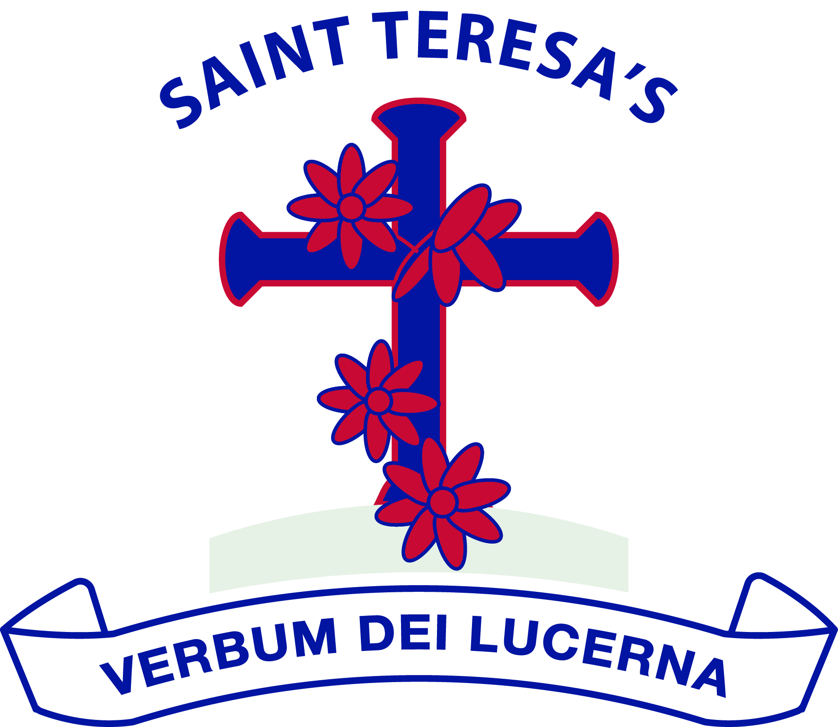

We love God and each other and follow the example of St Teresa.

We enjoy learning together and doing our best in a happy, healthy and welcoming community.

We learn to be responsible and caring citizens.

“Let us do little things well today”.

St Teresa

Approved by: | Governing Body | Date: February 2026
Last reviewed on: | February 2026
Next review due by: | February 2028

Scope:
This policy outlines the broad principles that will govern our approach to the induction of staff. It also provides guidance for managers to ensure that new staff members are provided with effective support to ensure they can fully meet the requirements of their job.

The key elements of this policy will be shared with the above-mentioned staff and also with governors. For the effective operation of this policy it is essential that staff are clear on their roles and responsibilities and that both theory and practice are followed consistently.

Relationship to School’s and Trust Aims:
This policy will be implemented in accordance with agreed values and aims of St. Teresa’s Primary School and The Rosary Trust.

Our principle aim is to make St. Teresa’s Primary a genuine learning community. Reference should also be made to other relevant policies including Performance Management, Health and Safety and Equal Opportunities.

Rationale:
We believe staff who are well supported and confident in their roles will be more successful in helping to achieve our school aims and values. Achievement of our vision, values and aims depends on recruiting, retaining and developing high quality staff. Integral to this objective is the need to provide a framework for the effective induction of newly appointed staff.

We regard effective planning for staff induction as being of prime importance. If new staff are to establish themselves quickly and effectively there is a need to provide them with guidance, support and information in a planned and considered way.

Goals:
These induction procedures aim to provide all newly appointed staff and those changing role with a programme of structured support and guidance as appropriate to their role to enable them to:
- Integrate successfully into the school;
- Develop their knowledge and skills in order to facilitate job satisfaction, motivation and quality of learning experience for all pupils;
- Be informed of school procedures and educational developments;
- Fulfil their Job Description successfully;
- Build confidence and expertise in the classroom and in other areas of responsibility;
- Be confident in asking for and receiving help;
- Identify their potential for career development and take advantage of opportunities for CPD.

Policy Content:
Roles and Responsibilities and Implementation Procedures
Although this policy is concerned mainly with the effective induction of new staff after appointment, it is important to regard the induction process as commencing with the initial contact between St. Teresa’s Primary and the prospective employee during the recruitment process.

Activity | With or  by whom | When | How / Notes
Pre-appointment
Relevant job details and application are sent to prospective applicants | Office Staff | On day requested | By email.  All details on the School website
There is an opportunity to visit the school prior to interview, including a tour of the school. | Head /  Y6 pupils | Date Agreed | Prospective candidate may collect job information at time of visit, organised by office staff.
Once Appointed
Inform staff and governors of new employee | Head | Following appointment | Note on whiteboard in staff room. Announcement in following staff meeting.  email
Carry out all appropriate  Pre-Employment checks | Office Staff | Immediately
Amend staff list to include new employee | Secretary | Before start date | Stored on school intranet
Update staff details in staff handbook | Office Staff | Before start date | Stored on school intranet
Draw up contract of employment | Office Staff | Within 1 week of appointment
Enter member of staff details onto computer system | Office Staff | Before start date
Prepare welcome letter | Office Staff | Weeks after appointment | Standard document on school system. Confirm date for pre start date visit to the school and contact point during holidays.
Preparation of timetables and rotas | Head / SLT | Prior to pre start visit | Teaching staff and TAs
Access to Curriculum Maps, planning etc | Mentor | Prior to pre start visit | Teaching staff and TAs
Preparation of pupil information to include groupings / levels / test results / personal and social info / SEN / medical | Previous class teacher | Prior to pre start visit | Teaching staff and relevant info for TAs

Induction Meetings
Induction meetings are held as soon as possible once started. These are usually held by the Headteacher although they can be delegated to other Senior Leaders or the School Business Manager.

Early Career Teachers
Induction for early career teachers will be provided over a two-year period. In addition, they will also be allocated a mentor to provide professional advice and support throughout the year.

Administrative Staff
The School Business Manager is responsible for the appropriate induction advice and training. In addition to the information in the table above, induction should include:
- Training to implement ICT programs and school administrative procedures;
- Access to confidential information, where appropriate, on children, staff and resources;
- Opportunity to comment on policies and practices
An induction and review meeting should be held with the School Business Manager at the end of the first month and then termly during the first year to identify and provide relevant support.

Statutory Induction
Statutory induction for all staff includes:
- To receive a copy of the St Teresa’s Staff Handbook
- To receive a copy of the Rosary Trust Code of Conduct
- To attend an induction meeting led by the Headteacher/SLT
- Reading, agreeing and signing our Confidentiality Agreement
- Reading, agreeing and signing to a range of Safeguarding training according to role
- Classroom based staff mandatory training in:
- Catholic RSE
- Health and Hygiene
- TPP Overview
- All staff mandatory training in:
- Cyber Security
- Prevent Level 1
- KCSiE Level 2

Probation
After an appropriate period but before the probationary period is completed, staff will be invited to a meeting with the Headteacher or SLT to determine that they are meeting the requirements of their job description. If they are not meeting their job description targets will be introduced. Probationary periods can be extended if the job description is not being fully met.

Equal Opportunities
At St. Teresa’s Primary School we are aware of the importance of the provision of equal opportunities for all regardless of age, gender, religion or race. This policy complies with the aims and requirements as set out in our Equal Opportunities Policy.

Health and Safety
It is essential that all new staff have a clear understanding of Trust guidelines on Health and Safety and their roles and responsibilities within this. Health and Safety induction should include information on fire and other emergencies, accidents, first aid, risk assessments and child protection. Staff will be informed or procedures as part of their induction process and be given appropriate material for their information.
St Teresa’s Primary School adheres to the National Smoke Free regulations within both the school buildings and the school grounds.

Safeguarding
We require that all staff, governors and adult volunteers in school undergo a criminal record check. Temporary staff, work experience students and volunteers who work with the children will be made aware of the schools’ arrangements for child protection and of their responsibilities. They should not be left on their own with children at any time unless appropriate checks have been made. If they have not been made another member of staff should be present. If they have any concerns regarding a child they should report those concerns to the Headteacher.

Reviewed: Spring term 2026
Approved by Governors: February 2026
To be reviewed: Spring term 2028

