ST. TERESA’S CATHOLIC PRIMARY SCHOOL, LEXDEN, COLCHESTER

Uniform Policy
2026

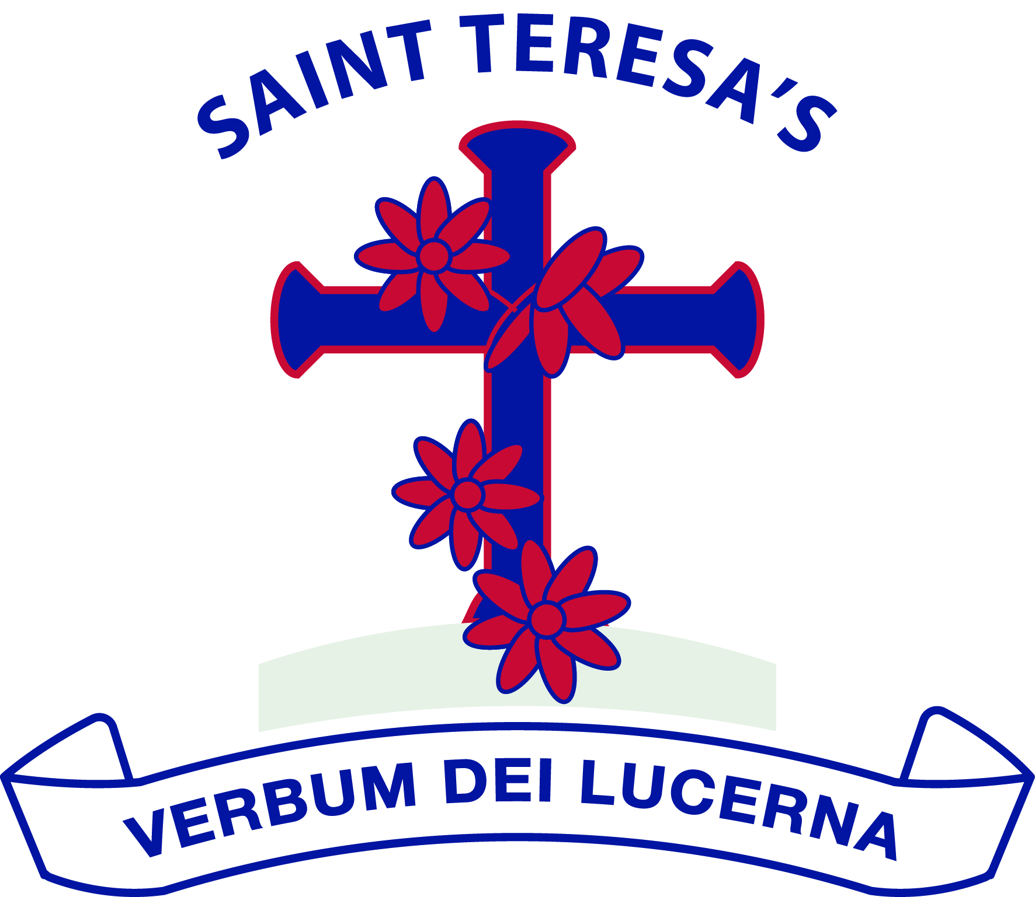

We love God and each other and follow the example of St Teresa.

We enjoy learning together and doing our best in a happy, healthy and welcoming community.

We learn to be responsible and caring citizens.

“Let us do little things well today”.

St Teresa

Approved by: | Governing Body | Date: February 2026
Last reviewed on: | February 2026
Next review due by: | February 2028

Mission and Ethos

At St Teresa’s Catholic Primary School, our school uniform is a visible sign of our belonging to a caring, faith-filled community. As a Catholic school, we believe each person is created in the image and likeness of God, and our uniform promotes dignity, equality and a sense of shared identity.

Our school logo features the cross, reminding us that Christ is at the centre of all we do. The colour blue, traditionally associated with Our Lady, reflects our school’s dedication to Mary and our commitment to virtues of gentleness, faith and service.

Wearing our uniform helps pupils feel part of our community, reduces pressure around fashion and cost, and supports a calm, focused learning environment.

This policy has been written in line with Department for Education guidance on the cost of school uniforms and aims to ensure uniform is affordable, practical and inclusive.

Aims of Our Uniform

Our uniform:

- Promotes a strong sense of belonging and community
- Reflects our Catholic identity and values
- Is practical, smart and suitable for learning
- Is affordable and widely available
- Reduces social pressure to wear fashionable or branded items

Availability and Affordability

We are committed to keeping uniform costs low.

- Most items can be purchased from a range of high street retailers and supermarkets
- Only a small number of items feature the school logo
- Our PTA, Friends of St Teresa’s (FOST), operate an ongoing second-hand uniform scheme where families can request items free of charge or for a small donation
- Second-hand uniform stalls are also available at school events

Families experiencing financial difficulty are encouraged to contact the school office in confidence.

Seasonal Uniform Expectations

We operate a winter and summer uniform.

- Winter uniform: October half term – Easter
- Summer uniform: Easter – October half term

Weather variations will always be considered, and flexibility will be applied where appropriate.

Winter Uniform

- White shirt
- School tie
- Branded school jumper or cardigan
- Grey trousers, grey skirt or grey pinafore (trousers may be worn by all pupils)
- Black school shoes (not trainers or boots)

Summer Uniform

- Branded school polo shirt (replaces shirt and tie)
- Branded school jumper or cardigan
- Grey trousers, grey skirt, grey pinafore or grey shorts (for all pupils)
- Optional Blue gingham summer dress
- Cycling shorts may be worn under summer dresses
- Black school shoes

Outerwear

We enjoy and take part n outdoor learning all year around and therefore we recommend:

- A waterproof coat (not branded)
- Wellies that stay in school all year around

PE Kit

On PE days, pupils should come to school wearing their PE kit:

- Plain navy-blue tracksuit top and bottoms or navy shorts
- Plain T-shirt in their house colour (red, yellow, blue or green)
- Trainers suitable for sports

Fashion or branded sportswear is not permitted as part of PE uniform.

Early Years & Key Stage 1 Bags

Children in EYFS and KS1 are expected to use a branded St Teresa’s book bag, which is provided free of charge when pupils start in Reception.

Nursery Uniform

Nursery children wear the same uniform as the main school; however, expectations are more relaxed. Uniform is encouraged to support belonging but is not compulsory, recognising the practical needs of younger children.

Hair, Jewellery and Appearance

To support safety and a smart appearance:

- Long hair must be tied back
- Only plain stud earrings may be worn
- Pupils must be able to remove earrings independently for PE lessons
- No other jewellery should be worn in school

Make-up, nail varnish and extreme hairstyles are not appropriate for primary school and are not permitted.

Footwear

Children should wear sensible, black school shoes. Trainers, fashion shoes or boots should not be worn as part of the main school uniform (trainers are for PE only).

Swimming Kit

Some pupils will take part in swimming lessons during the summer term. Parents will be informed in advance of the required swimwear and equipment. One-piece swimwear is required.

Equality and Inclusion

We are committed to ensuring our uniform is inclusive and does not disadvantage any pupil. Adaptations will be considered for:

- Religious requirements
- Cultural dress
- Medical or sensory needs

Parents should contact the Headteacher to discuss individual circumstances.

Consequences for incorrect uniform:

Pupils will be asked to ensure their uniform meets the expected standards. For example, a child with their hair down will be asked to tie it up, a child with incorrect PE kit will be asked to ensure its correct next time. If uniform policy is repeatedly unfollowed and after verbal reminders a letter will be sent home. The school reserve the right to use the uniform policy alongside the behaviour policy for repeated uniform concerns.

Monitoring and Review

The school works in partnership with families to maintain high standards of uniform. Where concerns arise, these will be addressed sensitively and supportively.

This policy will be reviewed regularly to ensure it remains affordable, inclusive and in line with DfE guidance.

Next due for review:
February 2028

