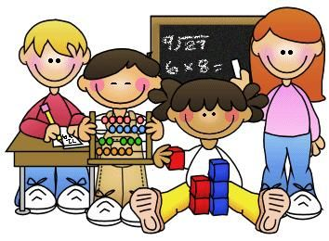
 | Reception | Year 1 | Year 2 | Year 3 | Year 4 | Year 5 | Year 6
Place value and number  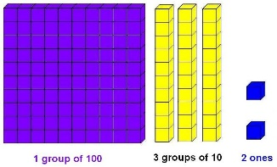 | Number zero one, two, three … to twenty none how many …? count, count (up) to, count on (from, to), count back (from, to) count in ones, twos, is the same as more, less odd, even few pattern pair Place value ones tens digit the same number as, as many as more, larger, bigger, greater fewer, smaller, less fewest, smallest, least most, biggest, largest, greatest one more, ten more one less, ten less compare order size first, second, third… twentieth last, last but one before, after next between | ones tens digit the same number as, as many as more, larger, bigger, greater fewer, smaller, less fewest, smallest, least most, biggest, largest, greatest one more, ten more | ones tens, hundreds digit one-, two- or three-digit number place, place value stands for, represents exchange the same number as, as many as more, larger, bigger, greater fewer, smaller, less fewest, smallest, least most, biggest, largest, greatest one more, ten more one less, ten less equal to compare order size first, second, third … twentieth twenty-first, twenty-second … last, last but one before, after next between halfway between above, below | ones tens, hundreds digit one-, two- or three-digit number place, place value stands for, represents exchange the same number as, as many as more, larger, bigger, greater fewer, smaller, less fewest, smallest, least most, biggest, largest, greatest one more, ten more, one hundred more one less, ten less, one hundred less equal to compare order size first, second, third … twentieth twenty-first, twenty-second … last, last but one before, after next between halfway between above, below | ones tens, hundreds digit one-, two- or three-digit number place, place value stands for, represents exchange the same number as, as many as more, larger, bigger, greater fewer, smaller, less fewest, smallest, least most, biggest, largest, greatest one more, ten more, one hundred more, one thousand more one less, ten less, one hundred less, one thousand less equal to compare order size first, second, third … twentieth twenty-first, twenty-second … last, last but on before, after next between halfway between above, below  negative numbers | ones tens, hundreds digit one-, two- or three-digit number place, place value stands for, represents exchange the same number as, as many as more, larger, bigger, greater fewer, smaller, less fewest, smallest, least most, biggest, largest, greatest one more, ten more, one hundred more, one thousand more one less, ten less, one hundred less, one thousand less equal to compare order size first, second, third … twentieth twenty-first, twenty-second … last, last but on before, after next between halfway between above, below  negative numbers | ones tens, hundreds digit one-, two- or three-digit number place, place value stands for, represents exchange the same number as, as many as more, larger, bigger, greater fewer, smaller, less fewest, smallest, least most, biggest, largest, greatest one more, ten more, one hundred more, one thousand more one less, ten less, one hundred less, one thousand less equal to compare order size first, second, third … twentieth twenty-first, twenty-second … last, last but on before, after next between halfway between above, below  negative numbers
Addition  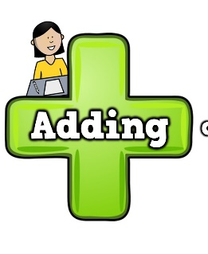 | more, and make, sum, total altogether double one more, two more … how many more to make …? how many more is … than …? how much more is …? between | addition add, more, and make, sum, total altogether double near double half, halve one more, two more … ten more how many more to make …? how many more is … than …? how much more is …? | Addition,add, more, and make, sum, total altogether double near double half, halve one more, two more … ten more … one hundred more how many more to make …? how many more is … than …? how much more is …? | addition add, more, and make, sum, total altogether double near double half, halve one more, two more … ten more … one hundred more how many more to make …? how many more is … than …? how much more is …? | Addition add, more, and make, sum, total altogether double near double half, halve one more, two more… ten more… one hundred more how many more to make …? how many more is … than …? how much more is …? | Addition add, more, and make, sum, total altogether double near double half, halve one more, two more… ten more… one hundred more how many more to make …? how many more is … than …? how much more is …? | Addition add, more, and make, sum, total altogether double near double half, halve one more, two more… ten more… one hundred more how many more to make …? how many more is … than …? how much more is …?
Subtraction  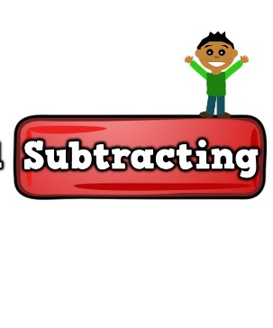 | take away how many are left/left over? how many have gone? one less, two less, ten less … how many fewer is … than …? how much less is …? difference | subtract take away how many are left/left over? how many have gone? one less, two less, ten less … how many fewer is … than …? how much less is …? difference between equals is the same as number bonds/pairs missing number | subtract take away how many are left/left over? how many have gone? one less, two less, ten less … one hundred less how many fewer is … than …? how much less is …? difference between equals is the same as number bonds/pairs/facts tens boundary | subtract take away how many are left/left over?  how many have gone? one less, two less, ten less … one hundred less how many fewer is … than …? how much less is …? difference between equals is the same as number bonds/pairs/facts missing number tens boundary, hundreds boundary | subtract take away how many are left/left over? how many have gone? one less, two less, ten less … one hundred less how many fewer is … than …? how much less is …? | subtract take away how many are left/left over? how many have gone? one less, two less, ten less … one hundred less how many fewer is … than …? how much less is …? | Subtract take away how many are left/left over? how many have gone? one less, two less, ten less … one hundred less how many fewer is … than …? how much less is …?
Multiplication  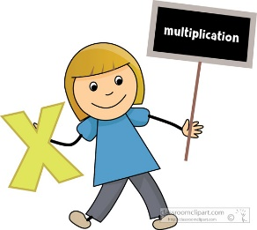 | Groups of  doubling number patterns | Multiplication multiply multiplied by multiple  Lots of groups of | Multiplication multiply multiplied by multiple groups of times once, twice, three times … ten times repeated addition | Multiplication multiply multiplied by multiple, factor groups of times product once, twice, three times … ten times repeated addition multiplication table multiplication fact, array row, column | Multiplication multiply multiplied by multiple, factor groups of times product once, twice, three times … ten times repeated addition square, squared cube, cubed | Multiplication multiply multiplied by multiple, factor groups of times product once, twice, three times … ten times repeated addition square, squared cube, cubed | Multiplication multiply multiplied by multiple, factor groups of times product once, twice, three times … ten times repeated addition square, squared cube, cubed
Division  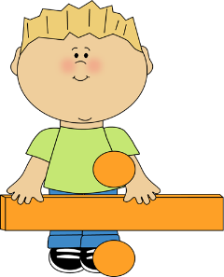 | sharing halving | division dividing grouping sharing doubling halving array number patterns | division dividing, divide, divided by, divided into grouping sharing, share, share equally left, left over one each, two each, three each … ten each group in pairs, threes … tens equal groups of doubling halving array row, column number patterns multiplication table multiplication fact, division fact | division dividing, divide, divided by, divided into left, left over, remainder grouping sharing, share, share equally one each, two each, three each … ten each group in pairs, threes … tens equal groups of doubling halving number patterns division fact | division dividing, divide, divided by, divided into left, left over, remainder grouping sharing, share, share equally one each, two each, three each … ten each group in pairs, threes … tens equal groups of doubling halving array row, column number patterns multiplication table multiplication fact, division fact inverse | division dividing, divide, divided by, divided into left, left over, remainder grouping sharing, share, share equally one each, two each, three each … ten each group in pairs, threes … tens equal groups of doubling halving array row, column number patterns multiplication table multiplication fact, division fact inverse  tenths | division dividing, divide, divided by, divided into left, left over, remainder grouping sharing, share, share equally one each, two each, three each … ten each group in pairs, threes … tens equal groups of doubling halving array row, column number patterns multiplication table multiplication fact, division fact inverse  tenths
Fractions  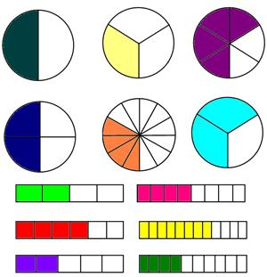 | Fractions parts of a whole half quarter | Fractions fraction equal part equal grouping equal sharing parts of a whole half one of two equal parts quarter one of four equal parts | Fractions fraction equivalent fraction mixed number numerator, denominator equal part equal grouping equal sharing parts of a whole half, two halves one of two equal parts quarter, two quarters, three quarters one of four equal parts one third, two thirds one of three equal parts | Fractions fraction equivalent fraction mixed number numerator, denominator equal part equal grouping equal sharing parts of a whole half, two halves one of two equal parts quarter, two quarters, three quarters one of four equal parts one third, two thirds one of three equal parts sixths, sevenths, eighths, tenths … | fraction equivalent fraction mixed number numerator, denominator equal part equal grouping equal sharing parts of a whole half, two halves one of two equal parts quarter, two quarters, three quarters one of four equal parts one third, two thirds one of three equal parts sixths, sevenths, eighths, tenths … hundredths decimal, decimal fraction, decimal point, decimal place, decimal equivalent proportion | fraction, proper/improper fraction equivalent fraction mixed number numerator, denominator equivalent, reduced to, cancel equal part equal grouping equal sharing parts of a whole half, two halves one of two equal parts quarter, two quarters, three quarters one of four equal parts one third, two thirds one of three equal parts sixths, sevenths, eighths, tenths … hundredths, thousandths decimal, decimal fraction, decimal point, decimal place, decimal equivalent proportion, in every, for every percentage, per cent, % | fraction, proper/improper fraction equivalent fraction mixed number numerator, denominator equivalent, reduced to, cancel equal part equal grouping equal sharing parts of a whole half, two halves one of two equal parts quarter, two quarters, three quarters one of four equal parts one third, two thirds one of three equal parts sixths, sevenths, eighths, tenths … hundredths, thousandths decimal, decimal fraction, decimal point, decimal place, decimal equivalent proportion, in every, for every percentage, per cent, %, ratio
Measurement  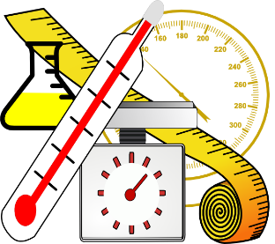 | measure size compare guess, estimate enough, not enough too much, too little too many, too few nearly, close to, about the same as just over, just under Length metre length, height, width, depth long, short, tall high, low wide, narrow thick, thin longer, shorter, taller, higher … and so on longest, shortest, tallest, highest … and so on far, near, close Weight weigh, weighs, balances heavy, light heavier than, lighter than heaviest, lightest scales Capacity and volume full empty half full holds container time days of the week, Monday, Tuesday … day, week birthday, holiday morning, afternoon, evening, night bedtime, dinner time, playtime today, yesterday, tomorrow before, after next, last now, soon, early, late quick, quicker, quickest, quickly slow, slower, slowest, slowly old, older, oldest new, newer, newest takes longer, takes less time hour, o’clock clock, watch, hands | measure measurement size compare guess, estimate enough, not enough too much, too little too many, too few nearly, close to, about the same as roughly just over, just under Length centimetre, metre length, height, width, depth long, short, tall high, low wide, narrow thick, thin longer, shorter, taller, higher … and so on longest, shortest, tallest, highest … and so on far, near, close ruler metre stick Weight kilogram, half kilogram weigh, weighs, balances heavy, light heavier than, lighter than heaviest, lightest scales litre, half litre capacity volume full empty more than less than half full quarter full holds container Time time days of the week, Monday, Tuesday … months of the year (January, February ...) seasons: spring, summer, autumn, winter day, week, weekend, month, year birthday, holiday morning, afternoon, evening, night bedtime, dinner time, playtime today, yesterday, tomorrow before, after earlier, later next, first, last midnight date now, soon, early, late quick, quicker, quickest, quickly slow, slower, slowest, slowly old, older, oldest new, newer, newest takes longer, takes less time how long ago? how long will it be to …? how long will it take to …? how often? always, never, often, sometimes | MEASUREMENT measure measurement size compare measuring scale Length centimetre, metre length, height, width, depth long, short, tall high, low wide, narrow thick, thin longer, shorter, taller, higher … and so on longest, shortest, tallest, highest … and so on far, further, furthest, near, close ruler metre stick, tape measure Weight kilogram, half kilogram, gram weigh, weighs, balances heavy, light heavier than, lighter than heaviest, lightest scales Capacity and volume litre, half litre, millilitre capacity volume full empty more than less than half full quarter full holds, contains container Temperature temperature degree Time time days of the week, Monday, Tuesday … months of the year (January, February ...) seasons: spring, summer, autumn, winter day, week, weekend, fortnight, month, year birthday, holiday morning, afternoon, evening, night bedtime, dinnertime, playtime today, yesterday, tomorrow before, after earlier, later next, first, last midnight date now, soon, early, late quick, quicker, quickest, quickly slow, slower, slowest, slowly old, older, oldest new, newer, newest takes longer, takes less time how long ago? how long will it be to …? how long will it take to …? how often? always, never, often, sometimes usually once, twice hour, o’clock, half past, quarter past, quarter to 5, 10, 15 … minutes past | measure  Length millimetre, centimetre, metre, kilometre, mile length, height, width, depth long, short, tall high, low wide, narrow thick, thin longer, shorter, taller, higher … and so on longest, shortest, tallest, highest … and so on far, further, furthest, near, close distance apart … between … to … from perimeter ruler metre stick, tape measure Weight kilogram, half kilogram, gram weigh, weighs, balances heavy, light heavier than, lighter than heaviest, lightest scales  Capacity and volume litre, half litre, millilitre capacity volume full empty more than less than half full quarter full holds, contains container Temperature temperature degree centigrade Time time days of the week, Monday, Tuesday … months of the year (January, February ...) seasons: spring, summer, autumn, winter day, week, weekend, fortnight, month, year, century birthday, holiday morning, afternoon, evening, night bedtime, dinner time, playtime today, yesterday, tomorrow before, after earlier, later next, first, last midnight calendar, date now, soon, early, late, earliest, latest quick, quicker, quickest, quickly slow, slower, slowest, slowly old, older, oldest new, newer, newest takes longer, takes less time how long ago? how long will it be to …? how long will it take to …? how often? always, never, often, sometimes usually once, twice hour, o’clock, half past, quarter past, quarter to 5, 10, 15 … minutes past a.m., p.m. clock, clock face, watch, hands digital/analogue clock/watch, timer hour hand, minute hand hours, minutes, seconds Roman numerals 12-hour clock time, 24-hour clock time | Length millimetre, centimetre, metre, kilometre, mile length, height, width, depth, breadth long, short, tall high, low wide, narrow thick, thin longer, shorter, taller, higher … and so on longest, shortest, tallest, highest … and so on far, further, furthest, near, close distance apart … between … to … from edge, perimeter area, covers square centimetre (cm2 ) ruler metre stick, tape measure Weight mass: big, bigger, small, smaller weight: heavy/light, heavier/lighter, heaviest/ lightest kilogram, half kilogram, gram weigh, weighs, balances heavy, light heavier than, lighter than heaviest, lightest scales Capacity and volume litre, half litre, millilitre capacity volume full empty more than less than half full quarter full holds, contains container, measuring cylinder Temperature temperature degree centigrade Time time days of the week, Monday, Tuesday … months of the year (January, February ...) seasons: spring, summer, autumn, winter day, week, weekend, fortnight, month, year, leap year, century, millennium birthday, holiday morning, afternoon, evening, night bedtime, dinner time, playtime today, yesterday, tomorrow before, after earlier, later next, first, last noon, midnight calendar, date, date of birth now, soon, early, late, earliest, latest quick, quicker, quickest, quickly slow, slower, slowest, slowly old, older, oldest new, newer, newest takes longer, takes less time how long ago? how long will it be to …? how long will it take to …? how often? always, never, often, sometimes usually once, twice hour, o’clock, half past, quarter past, quarter to | Length millimetre, centimetre, metre, kilometre, mile length, height, width, depth, breadth long, short, tall high, low wide, narrow thick, thin longer, shorter, taller, higher … and so on longest, shortest, tallest, highest … and so on far, further, furthest, near, close distance apart … between … to … from edge, perimeter area, covers square centimetre (cm2 ) square m, (m ²) square mm, (mm ²) ruler metre stick, tape measure Weight mass: big, bigger, small, smaller weight: heavy/light, heavier/lighter, heaviest/ lightest kilogram, half kilogram, gram weigh, weighs, balances heavy, light heavier than, lighter than heaviest, lightest scales Capacity and volume litre, half litre, millilitre capacity volume full empty more than less than half full quarter full holds, contains container, measuring cylinder pint gallonTemperature temperature degree centigrade Time time days of the week, Monday, Tuesday … months of the year (January, February ...) seasons: spring, summer, autumn, winter day, week, weekend, fortnight, month, year, leap year, century, millennium birthday, holiday morning, afternoon, evening, night bedtime, dinner time, playtime today, yesterday, tomorrow before, after earlier, later next, first, last noon, midnight calendar, date, date of birth now, soon, early, late, earliest, latest quick, quicker, quickest, quickly slow, slower, slowest, slowly old, older, oldest new, newer, newest takes longer, takes less time how long ago? how long will it be to …? how long will it take to …? how often? always, never, often, sometimes usually once, twice hour, o’clock, half past, quarter past, quarter to | Length millimetre, centimetre, metre, kilometre, mile,yard, foot, feet, inch, inches length, height, width, depth, breadth long, short, tall high, low wide, narrow thick, thin longer, shorter, taller, higher … and so on longest, shortest, tallest, highest … and so on far, further, furthest, near, close distance apart … between … to … from edge, perimeter area, circumference, covers square centimetre (cm2 ) square m, (m ²) square mm, (mm ²) ruler metre stick, tape measure Weight mass: big, bigger, small, smaller weight: heavy/light, heavier/lighter, heaviest/ lightest kilogram, half kilogram, gram weigh, weighs, balances heavy, light heavier than, lighter than heaviest, lightest scales punds ounces Capacity and volume litre, half litre, millilitre capacity centilitre cubic centimetres(cm3 ), cubic metres (m3 ), cubic millimetres (mm3 ), cubic kilometres (km3 )volume full empty more than less than half full quarter full holds, contains container, measuring cylinder pint gallon Temperature degree centigrade Time time days of the week, Monday, Tuesday … months of the year (January, February ...) seasons: spring, summer, autumn, winter day, week, weekend, fortnight, month, year, leap year, century, millennium before, after earlier, later next, first, last noon, midnight calendar, date, date of birth now, soon, early, late, earliest, latest quick, quicker, quickest, quickly slow, slower, slowest, slowly old, older, oldest new, newer, newest takes longer, takes less time how long ago? how long will it be to …? how long will it take to …? how often? Greenwich Mean Time, British Summer Time, International Date Line
Geometry  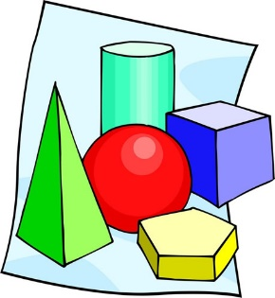 | Circle  Square  Rectangle  Triangle  Corner  Edge  Sides  Pentagon  What’s the same? What’s different?  Straight  Curved  More  Less  face, edge, vertex, vertices cube pyramid sphere cone | Circle  Square  Rectangle  Triangle  Corner  Edge  Sides  Pentagon  What’s the same? What’s different?  Straight  Curved  More  Less  face, edge, vertex, vertices cube pyramid sphere cone | Properties of shape shape, pattern flat curved, straight round hollow, solid sort make, build, draw surface size bigger, larger, smaller symmetry, symmetrical, symmetrical pattern line symmetry pattern, repeating pattern match 2-D shape corner, side point, pointed rectangle (including square), rectangular circle, circular triangle, triangular pentagon hexagon octagon 3-D shape face, edge, vertex, vertices cube, cuboid pyramid sphere cone cylinder Position and direction position over, under, underneath above, below top, bottom, side on, in outside, inside around in front, behind front, back beside, next to opposite apart between middle, edge centre corner direction journey, route left, right | flat curved, straight round hollow, solid sort make, build, draw perimeter surface size bigger, larger, smaller symmetry, symmetrical, symmetrical pattern line symmetry pattern, repeating pattern match 2-D shape corner, side point, pointed rectangle (including square), rectangular circle, circular triangle, triangular pentagon, pentagonal hexagon, hexagonal octagon, octagonal quadrilateral right-angled parallel, perpendicular 3-D shape face, edge, vertex, vertices cube, cuboid pyramid sphere, hemisphere cone cylinder prism, triangular prism | Properties of shape perimeter centre surface angle, right-angled base, square-based size bigger, larger, smaller symmetry, symmetrical, line symmetry reflect, reflection pattern, pattern match regular, irregular 2-D shape 2-D, two-dimensional rectilinear circle, circular triangle, triangular equilateral triangle, isosceles triangle, scalene triangle pentagon, pentagonal hexagon, hexagonal heptagon octagon, octagonal quadrilateral parallelogram, rhombus, trapezium polygon right-angled parallel, perpendicular 3-D shape 3-D, three-dimensional face, edge, vertex, vertices cube, cuboid pyramid sphere, hemisphere, spherical cone cylinder, cylindrical prism, triangular prism tetrahedron, polyhedron | hollow, solid sort make, build, construct, draw, sketch perimeter centre, radius, diameter surface angle, right-angled congruent base, square-based size bigger, larger, smaller symmetry, symmetrical, symmetrical pattern line symmetry reflect, reflection axis of symmetry, reflective symmetry pattern, repeating pattern match  x-axis, y-axis, quadrant regular, irregular  shapes ad above including octahedron, | circumference, concentric, arc net, open, closed intersecting, intersection plane hollow, solid sort make, build, construct, draw, sketch perimeter centre, radius, diameter surface angle, right-angled congruent base, square-based size bigger, larger, smaller symmetry, symmetrical, symmetrical pattern line symmetry reflect, reflection axis of symmetry, reflective symmetry pattern, repeating pattern match  x-axis, y-axis, quadrant regular, irregular  shapes ad above including octahedron,
Statistics   |  |  | STATISTICS count, tally, sort, vote graph, block graph, pictogram represent group, set list, table label, title most popular, most common least popular, least common | count, tally, sort, vote graph, block graph, pictogram represent group, set list, table, chart, bar chart, frequency table Carroll diagram, Venn diagram label, title, axis, axes diagram most popular, most common least popular, least common | count, tally, sort, vote survey, questionnaire, data graph, block graph, pictogram represent group, set list, table, chart, bar chart, frequency table Carroll diagram, Venn diagram label, title, axis, axes diagram most popular, most common least popular, least common | count, tally, sort, vote survey, questionnaire, data, database graph, block graph, pictogram represent group, setlist, table, chart, bar chart, frequency table, bar line chart Carroll diagram, Venn diagram line graph label, title, axis, axes diagram most popular, most common least popular, least common maximum/minimum value outcome | count, tally, sort, vote survey, questionnaire, data, database graph, block graph, pictogram represent group, setlist, table, chart, bar chart, frequency table, bar line chart Carroll diagram, Venn diagram line graph label, title, axis, axes diagram most popular, most common least popular, least common maximum/minimum value outcome mean (mode, median, range as estimates for this) statistics, distribution pie chart  mean mode
Position and Direction   | position over, under above, below top, bottom, side on, in outside, inside around in front, behind front, back beside, next to opposite apart between middle, edge corner direction left, right up, down forwards, backwards, sideways | position over, under above, below top, bottom, side on, in outside, inside around in front, behind front, back beside, next to opposite apart between middle, edge corner direction left, right up, down forwards, backwards, sideways | up, down higher, lower forwards, backwards, sideways across next to, close, near, far along through to, from, towards, away from clockwise, anticlockwise movement slide roll turn stretch, bend whole turn, half turn, quarter turn, three-quarter turn right angle straight line | over, under, underneath above, direction journey, route left, right up, down higher, lower forwards, backwards, sideways across next to, close, near, far along through to, from, towards, away from clockwise, anticlockwise compass point north, south, east, west, N, S, E, W horizontal, vertical, diagonal movement slide roll turn stretch, bend whole turn, half turn, quarter turn, three-quarter turn angle … is a greater/smaller angle than right angle | clockwise, anticlockwise compass point north, south, east, west, N, S, E, W north-east, north-west, south-east, south-west, NE, NW, SE, SW horizontal, vertical, diagonal translate, translation whole turn, half turn, quarter turn, three-quarter turn rotate, rotation angle, is a greater/smaller angle than degree right angle acute angle obtuse angle reflection straight line ruler, set square angle measurer, compass | clockwise, anticlockwise compass point north, south, east, west, N, S, E, W north-east, north-west, south-east, south-west, NE, NW, SE, SW horizontal, vertical, diagonal translate, translation whole turn, half turn, quarter turn, three-quarter turn rotate, rotation angle, is a greater/smaller angle than degree right angle acute angle obtuse angle reflection straight line ruler, set square angle measurer, compass co-ordinates  protractor | clockwise, anticlockwise compass point north, south, east, west, N, S, E, W north-east, north-west, south-east, south-west, NE, NW, SE, SW horizontal, vertical, diagonal translate, translation whole turn, half turn, quarter turn, three-quarter turn rotate, rotation angle, is a greater/smaller angle than degree right angle acute angle obtuse angle reflection straight line ruler, set square angle measurer, compass co-ordinates  protractor
Algebra  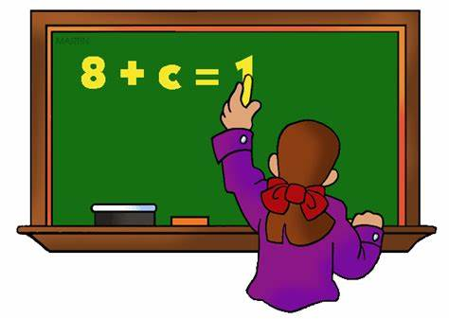 |  |  |  |  | Missing numbers  Balancing equations | Missing numbers  Balancing equations  Rule  Follow the rule  Equals  Equality | Algebra formula, formulae equation unknown variable
Reasoning  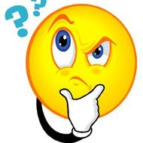 | I notice  I think  I know… therefore I think  I conjecture  The rule is  The pattern is  I estimate  What could we try next? How did you work it out? recognise describe draw compare sort  Explain your thinking  Solve the problem!  Mental method  Mentally  Calculation  Written calculation  Make a statement about

