

St Teresa’s Catholic Primary School
Year 5 Mathematics Targets
Place value

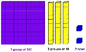
 | I can read, write, order and compare numbers up to at least 1,000,000 (one million) and say the value of each digit.
 | I can keep multiplying a number by 10 or 100 up to 1,000,000 and count back.
 | I can use negative numbers in context when looking at temperature or money, counting forwards and backwards through 0.
 | I can round numbers up to 1,000,000 to the nearest 10, 100, 1000, 10,000 or 100,000.
 | I can solve number and practical problems that involve ordering and comparing numbers up to 1,000,000, counting forwards or backwards in steps, negative numbers, and rounding.
 | I can read Roman numerals up to 1000 and recognise years written in them.
Addition and subtraction  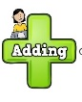 | I can add and subtract numbers with more than 4 digits using written methods.
 | I can add and subtract 2 and 3 digit numbers in my head.
 | I can use rounding to check answers to calculations and determine levels of accuracy.
 | I can solve addition and subtraction problems needing more than one step and can work out which operation and method is the most suitable.
Multiplication and division   | I can find multiples and factors of a number and can identify factors common to 2 different numbers.
 | I can use vocabulary relating to prime numbers, prime factors and composite numbers.
 | I can work out if any given number up to 100 is a prime number and can recall prime numbers up to 19.
 | I can multiply numbers with up to 4 digits by a 1 or 2 digit number using formal written methods.
 | I can mentally multiply and divide numbers using the times tables.
 | I can divide numbers with up to 4 digits by a 1 digit number, using formal written methods, and can show remainders.
 | I can multiply and divide whole and decimal numbers by 10, 100 and 1000.
 | I can identify and use square numbers and their notation.
 | I can identify and use cube numbers and their notation.
 | I can solve problems involving multiplication and division, including using factors and multiples, squares and cubes.
 | I can solve problems involving addition, subtraction, multiplication and division, and a combination of these, including understanding the meaning of the equals sign.
 | I can solve problems involving multiplication and division, including scaling by simple fractions and problems involving simple rates.
Fractions  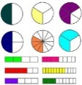 | I can compare and order fractions whose denominators are all multiples of the same number.
 | I can find and name equivalent fractions of a given fraction including tenths and hundredths.
 | I can write equivalent fractions of a given fraction including tenths and hundredths.
 | I can identify mixed numbers and improper fractions and convert from one to another such as 2/5 + 4/5 = 6/5 = 1 and 1/5.
 | I can add and subtract fractions whose denominators are all multiples of the same number.
 | I can multiply fractions by whole numbers using objects and pictures.
Decimals and percentage   | I can read and write decimal numbers as fractions such as 0.71 = 71/100.
 | I can identify and use thousandths and can explain how they relate to tenths and hundredths and their decimal equivalents.
 | I can round numbers with two decimal places.
 | I can read, write, order and compare numbers with up to three decimal places.
 | I can solve problems involving numbers with up to three decimal places.
 | I can solve problems which require knowing percentage and decimal equivalents of 1/2, 1/4, 1/5, 2/5, 4/5 and those fractions with a denominator of a multiple of 10 or 25.
 | I can identify the percent symbol (%) and how it relates to parts per hundred, hundredths and decimals.
Measurement  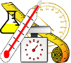 | I can convert between different forms of metric measurement e.g. kilometre and metre; centimetre and metre; centimetre and millimetre; gram and kilogram; litre and millilitre.
 | I can understand and compare equivalences between metric units and common imperial units. These might include: inches, pounds or pints.
Measurement: area, perimeter and volume | I can measure and calculate the perimeter of composite rectilinear shapes in centimetres and metres.
 | I can calculate and compare the area of rectangles (including squares), and including using standard units, square centimetres (cm²), square metres (m²), and estimate the area of irregular shapes.
 | I can estimate volume by using 1cm³ blocks to build cuboids(including cubes) and capacity by using water and different containers.
 | I can solve problems where I need to convert between units of time.
 | I can use all four operations to solve problems involving measure
Geometry  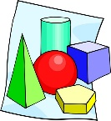 | I can identify 3-D shapes, including cubes and other cuboids, from 2-D representations.
 | I can estimate and compare acute, obtuse and reflex angles.
 | I know that angles are measured in degrees. I can identify other multiples of 90°.
 | I can draw given angles and measure them in degrees.
 | I can identify angles at a point and one whole turn.
 | Identify angles at a point on a straight line and 1/2 a turn (total 180°).
 | I can identify angles at a point on a straight line and ½ a turn (total 180°).
 | I can use the properties of rectangles to find related facts, missing lengths and missing angles.
 | I can tell the difference between regular and irregular polygons. I can do this using reasoning about equal sides and angles.
Position and direction  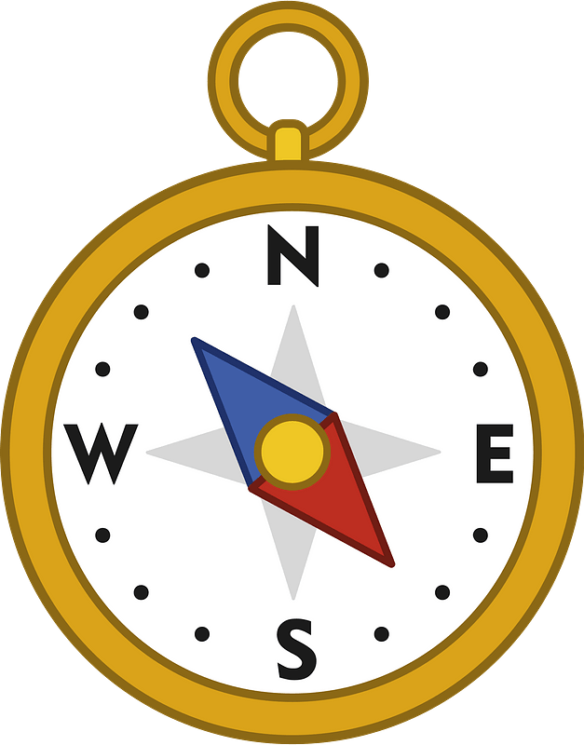 | I can identify, describe and represent the position of a shape following a reflection or translation.
 | I can use mathematical vocabulary to explain this and I know that the shape has not changed.
Statistics   | I can solve comparison, sum and difference problems using information presented in a line graph.
 | I can complete, read and interpret information in tables, including timetables.

