

St Teresa’s Catholic Primary School
Year 4 Mathematics Targets
Place value

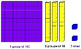

 | I can count in multiples of 6, 7, 9, 25 and 1000.
 | I can find 1000 more or less than a given number.
 | I can count backwards through 0 to include negative numbers.
 | I can recognise the place value of each digit of a 4 digit number (thousands, hundreds, tens and units).
 | I can order and compare numbers beyond 1000.
 | I can identify, represent and estimate numbers, including measures, using different representations.
 | I can round numbers to the nearest 10, 100 or 1000.
 | I can solve number and practical problems that involve large positive numbers.
 | I can read Roman numerals up to 100 and know that the number system has changed to include 0 and place value.
Addition and subtraction  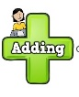 | I can add numbers with up to four digits using the formal column method.
 | I can subtract numbers with up to four digits using the formal column method.
 | I can use estimating and inverse operations to check my answers.
 | I can solve two step addition and subtraction problems, using different methods and explain why I used them.
Multiplication and division   | I can recall times tables facts up to 12 x 12.
 | I can use place value and number facts to multiply and divide mentally, including multiplying by 1 and 0; dividing by 1; and multiplying together 3 numbers.
 | I can use factor pairs in mental calculations.
 | I can multiply two digit and three digit numbers by a one digit number using a formal written method.
 | I can solve problems involving multiplication and addition, including using the distributive law e.g. 3 x (12 + 14) = 3 x 12 + 3 x 14.
Fractions  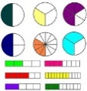 | I can recognise and show, using diagrams, families of common equivalent fractions.
 | I can count up and down in hundredths and know that dividing an object by 100 creates hundredths as does dividing tenths by ten.
 | I can solve problems involving fractions to calculate quantities and fractions to divide quantities.
 | I can add and subtract fractions with the same denominator.
 | I can find and write decimal equivalents using tenths and hundredths.
 | I can find and write decimal equivalents of 1/4, 1/2 and 3/4.
Decimals  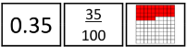 | I can divide one and two digit numbers by 10 and 100 and can explain the effect this has on place value.
 | I can round decimals using tenths to the nearest whole number.
 | I can compare numbers with the same number of decimal places (up to two decimal places).
 | I can solve simple money and measure problems involving fractions, and decimals with up to two decimal places.
Measurement: money  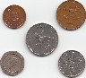 | I can estimate, compare and calculate different measures, including money in pounds and pence.
Measurement: time  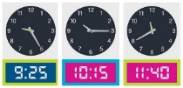 | I can read, write and compare time between analogue and digital 12-hour and 24-hour clocks.
 | I can solve problems where I need to convert units of time such as hours to minutes, minutes to seconds, years to months or weeks to days.
Measurement:  Length, area and perimeter  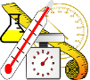 | I can convert different units of measurement e.g. I can convert kilometres into metres or hours into minutes.
 | I can measure and calculate the perimeter of a rectilinear figure (Including squares) in centimetres and metres.
 | I can find the area of rectilinear shapes by counting squares.
Geometry: shape  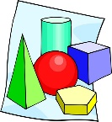 | I can compare and classify geometric shapes, including quadrilaterals and triangles, based on their properties and sizes.
 | I can identify acute and obtuse angles. I can compare and order angles up to two right angles by size.
 | I can identify lines of symmetry in 2-D shapes presented in different orientations.
 | I can complete a simple symmetric figure with respect to a specific line of symmetry.
 | I can recognise where angles are greater than two right angles. I know the term straight angle refers to two right angles together.
Geometry: position and direction  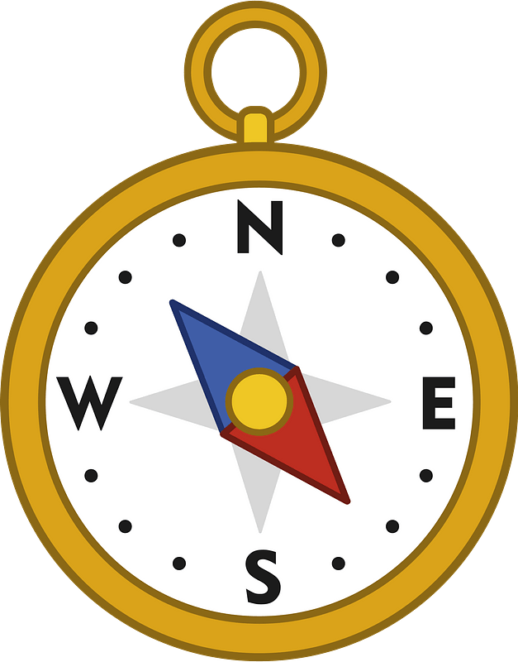 | I can plot positions on a 2-D grid as positive number coordinates.
 | I can describe movements between positions as translations of a given unit to the left/right and up/down.
 | I can plot points I am given and draw sides to complete a given polygon.
Statistics   | I can interpret and present discrete and continuous data using appropriate graphical methods, including bar charts and time graphs.
 | I can solve comparison, sum and difference problems using information presented in bar charts, pictograms, tables and other graphs.

