

St Teresa’s Catholic Primary School
Year 2 Mathematics Targets
Place value

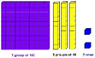
 | I can say how much numbers are worth in a bigger number
 | I can count forward and backwards in jumps of 2, 3 and 5 from 0 and in 10s from any number.
 | I can find the place value of each digit of a number with tens and units.
 | I can find and show numbers using different equipment such as number lines and number squares.
 | I can compare and order numbers from 0 to 100 using <, > and =.
 | I can read and write numbers up to 100 in numbers.
 | I can read and write numbers up to 100 in words.
 | I can use place value and number facts to answer questions.
 | I can partition two-digit numbers into different combinations of tens and ones using apparatus.
 | I can use reasoning within addition.
 | I can recall the multiples of 10 below and above any 2 digit number.
Addition and subtraction  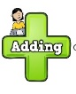 | I can solve problems with addition and subtraction, including those involving numbers, quantities and measures by using objects or pictures.
 | I can answer simple addition and subtraction questions in my head as well as by writing them down.
 | I can use addition and subtraction facts to 20 quickly and work out similar facts to 100.
 | I can add and subtract a two digit number and a one digit number mentally and when using objects, number lines and pictures.
 | I can add and subtract a two digit number and tens mentally and when using objects, number lines and pictures.
 | I can add and subtract 2 two digit numbers mentally and when using objects, number lines and pictures.
 | I can add and subtract 3 one digit numbers mentally and when using objects, number lines and pictures.
 | I can show that adding 2 numbers can be done in any order but subtraction cannot.
 | I can show that subtraction is the opposite of addition and use this to check my work.
 | I can remember doubles and halves up to 20.
 | I can use estimation to check that my answers to a calculation make sense.
 | I can solve missing number problems using addition and subtraction.
Multiplication and division   | I can remember and use multiplication and division facts for the 2, 5 and 10 times tables and recognise odd and even numbers.
 | I can answer multiplication and division problems within the tables using x, ÷ and =.
 | I can show that multiplying 2 numbers can be done in any order but division cannot.
 | I can answer questions involving multiplication and division mentally and with objects.
 | I can answer questions involving multiplication and division using arrays and repeated addition.
 | I can use multiplication facts to make deductions outside known multiplication facts.
 | I can solve multiplication and division word problems with more than one step.
 | I can rewrite addition statements as simplified multiplication statements.
Fractions  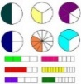 | I can find, name and write fractions of a length, shape, set of objects or amount, including 1/3, 1/4, 2/4, and 3/4.
 | I can write simple fractions facts such as 1/2 of 6 = 3 and
Measurement: money  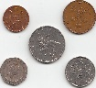 | I can use the £ sign and p sign. I can use notes and coins to make a particular amount.
 | I can find different ways for coins to add up to an amount.
 | I can add and subtract money and give change.
Measurement: time  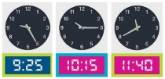 | I can put different events in order and compare them.
 | I can tell the time to 5 minutes. I can tell when it is quarter past or quarter to an hour. I can draw these on a clock.
 | I can tell you how many minutes are in an hour and how many hours are in a day.
 | I can read scales in divisions of ones, twos, fives and tens.
 | I can read scales in divisions of ones, twos, fives and tens when some numbers are missing.
 | I can read the time on a clock to the nearest quarter of an hour.
Measurement: length and height  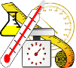 | I can choose the right units to measure length, height, mass, temperature or capacity.
 | I can read to the nearest unit and do this on rulers or scales.
 | I can compare amounts using these signs: >, < or =.
Measurement: mass and capacity | I can choose the right units to measure length, height, mass, temperature or capacity. I can read to the nearest unit and do this on rulers or scales.
 | I can compare amounts using these signs: >, < or =.
Geometry  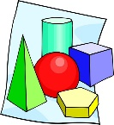 | I can notice and explain the properties of 2-D shapes e.g. the number of sides and line symmetry.
 | I can notice and explain the properties of 3-D shapes e.g. the number of edges, vertices and faces.
 | I can spot 2-D shapes on the surface of 3-D shapes such as a circle on a cylinder and a triangle on a pyramid.
 | I can compare and sort common 2-D and 3-D shapes and everyday objects.
Position and direction  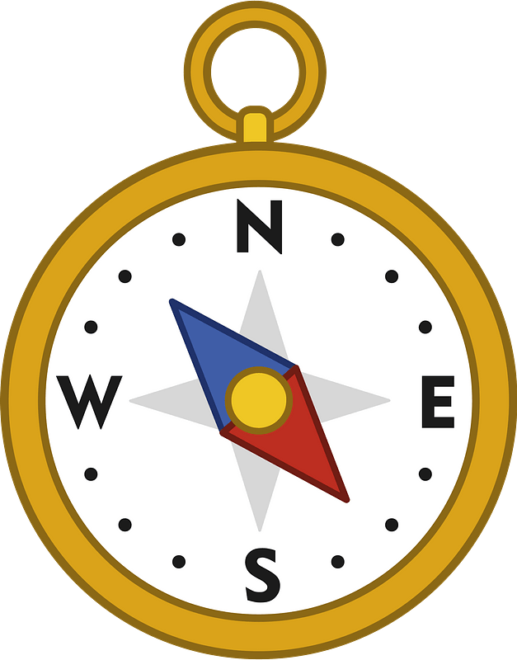 | I can order mathematical objects in patterns and sequences.
 | I can use mathematical vocabulary to describe position, direction and movement. This could include movement in a straight line.
Statistics   | I can read and draw simple pictograms, tally charts, block diagrams and simple tables.
 | I can ask and answer simple questions by counting the number of objects in each category and sorting the categories by quantity.
 | I can ask and answer questions about totalling and comparing grouped data.

