

St Teresa’s Catholic Primary School
Year 1 Mathematics Targets
Number and place value to 10

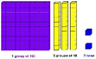
 | I can identify one more and one less, given a starting number.
 | I can find and show numbers using objects and pictures including number lines and use: equal to, more than, less than (fewer), most, least.
 | I can read and write numbers from 1 to 20 in numbers.
 | Read and write numbers from 1 to 20 in words.
 | I can read and write numbers from 1 to 20 in words.
Addition and subtraction to 10  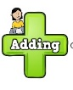 | I can read and understand number statements using +, - and =.
 | I can write number statements using +, - and =
 | I can use number bonds up to 20.
 | I can use subtraction facts up to 20.
 | I can add one digit and two digit numbers to 20.
 | I can subtract one digit and two digit numbers to 20.
 | I can answer problems that use addition and subtraction, including missing number problems, using objects and pictures.
Number and place value to 20 | I can identify one more and one less, given a starting number.
 | I can find and show numbers using objects and pictures including number lines and use: equal to, more than, less than (fewer), most, least.
 | I can read and write numbers from 1 to 20 in numbers.
 | Read and write numbers from 1 to 20 in words.
 | I can read and write numbers from 1 to 20 in words.
Addition and subtraction to 20 | I can read and understand number statements using +, - and =.
 | I can write number statements using +, - and =
 | I can use number bonds up to 20.
 | I can use subtraction facts up to 20.
 | I can add one digit and two digit numbers to 20.
 | I can subtract one digit and two digit numbers to 20.
 | I can answer problems that use addition and subtraction, including missing number problems, using objects and pictures.
Number and place value to 50 | I can count to and past 100, forwards and backwards starting from any number.
 | I can count and read numbers to 100 in numerals.
 | I can count and write numbers to 100 in numerals.
 | I can count in jumps of 2, 5 and 10
 | I can use counting to solve problems with bigger numbers.
 | I can partition and combine numbers using apparatus if I need it.
Number and place value to 100 | I can count to and past 100, forwards and backwards starting from any number.
 | I can count and read numbers to 100 in numerals.
 | I can count and write numbers to 100 in numerals.
 | I can count in jumps of 2, 5 and 10
 | I can use counting to solve problems with bigger numbers.
 | I can partition and combine numbers using apparatus if I need it.
Multiply and divide   | I can answer multiplication questions using objects, pictures and other equipment.
 | I can answer division questions using objects, pictures and other equipment.
Fractions  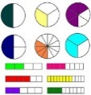 | I can find and name 1/2 (half) of an object, shape or amount.
 | I can find and name 1/4 (quarter) as one of four equal parts of an object, shape or amount.
Geometry: shape  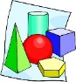 | I can recognise and name common 2-D shapes such as rectangles, squares, circles and triangles.
 | I can recognise and name common 3-D shapes such as
Geometry: position and direction  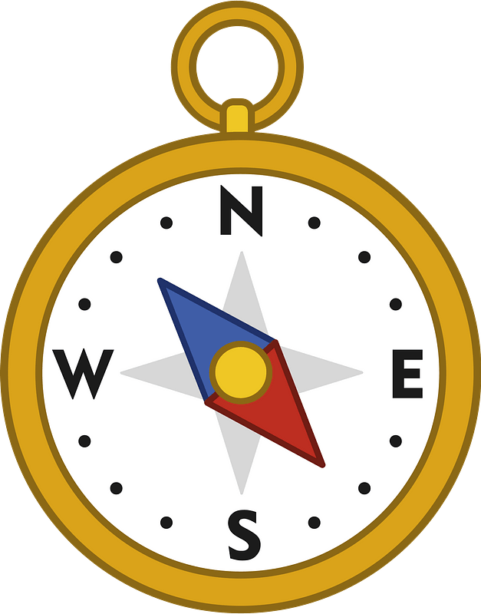 | I can talk about whole, half, quarter and three quarter turns.
 | I can then use this to explain movement, direction and position.
Measurement: length and height  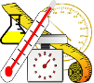 | I can solve problems for length and height by telling which objects are longer or shorter/taller or shorter.
 | Measure and begin to record length/height.
 | I can measure and begin to record length/height.
Measurement: weight and volume | I can solve problems for mass and weight by telling which objects are heavier or lighter.
 | I can solve problems for capacity and volume by telling if a container is empty, half full or full and if there is more in one container than another.
 | I can measure weight or mass and write these measurements down.
 | I can measure capacity or volume and write these measurements down.
Measurement: money  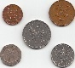 | I can tell how much different coins or notes are worth
Measurement: time  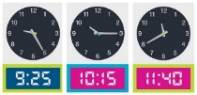 | I can tell when things happened by using these words: before, after, next, first, today, yesterday, tomorrow, morning, afternoon, evening.
 | I can talk about dates using the days of the week, weeks, months and years.
 | I can solve problems for time. I can tell if something is quicker or slower. I can tell if something happened earlier or later.
 | Tell the time to the hour and half past the hour and draw the hands on a clock face to show these times.
 | I can tell what the time is in hours and half past the hour.
 | I can draw these on a clock face.

